**Week-2**

**1.write a C program to find the area of a circle using the formula: Area= PI*r2**

**1Pseudocode:**

Begin

Declare float pi=3.1415,area,r

Take user input radius of the circle

Use area of circle formula to find the area of circle

area=pi*r*r

print area

end

**C program:**

#include<stdio.h>

void main()

{

const float pi=3.1415;

float area,r;

printf("enter radius of the circle:");

scanf("%f",&r);

area=pi*r*r;

printf("area of circle is %f",area);

}

**Output:**

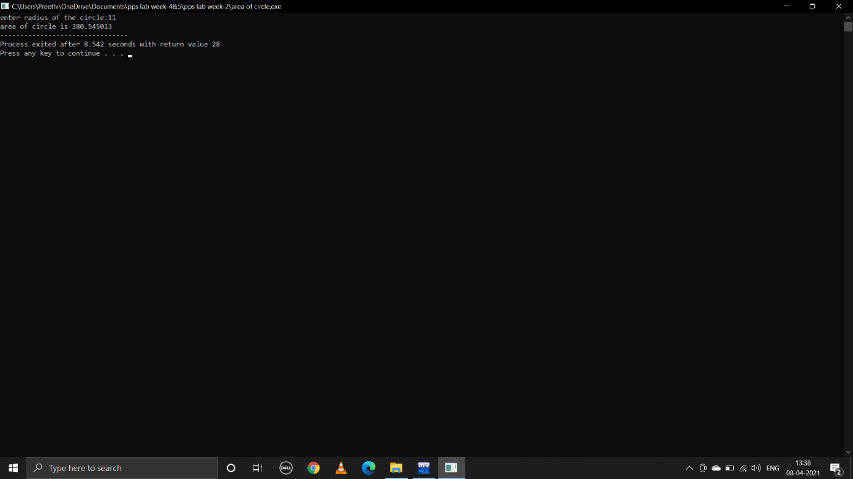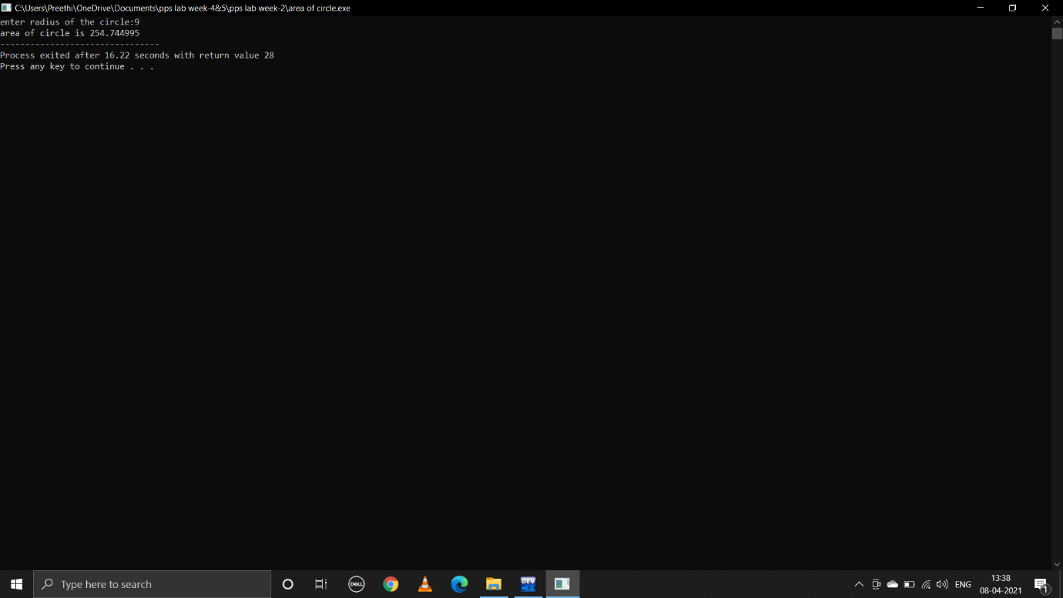

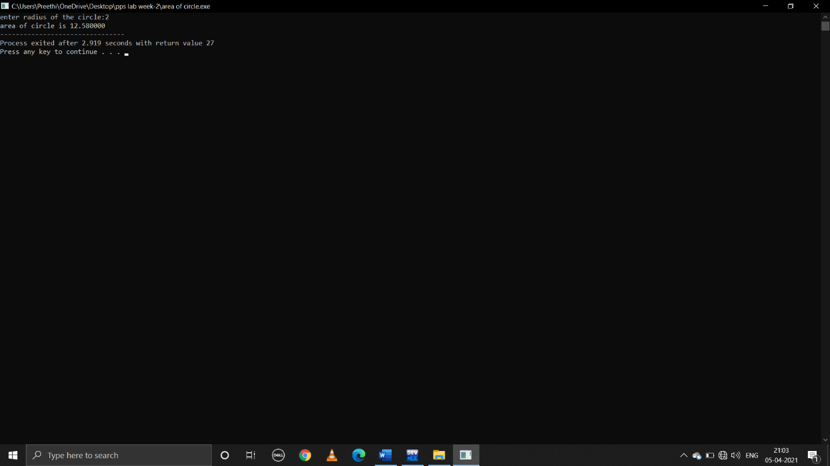

**2.write a C program to find the area and volume of sphere.**

**Formulas are:Area=4*PI*R*R Volume=4/3*PI*R*R*R**

**Pseudocode:**

Start

Declare float pi=3.1415,r,area,volume

Take user input radius of the sphere

To find area of the sphere use formula

area=4*pi*r*r

to find volume of the sphere use formula

volume=(4*pi*r*r*r)/3

print area and volume

end

**C program:**

#include<stdio.h>

void main()

{

const float pi=3.1415;

float r,area,volume;

printf("enter radius of the sphere:");

scanf("%f",&r);

area=4*pi*r*r;

volume=(4*pi*r*r*r)/3;

printf("area sphere is %f",area);

printf("\n");

printf("volume of sphere is %f",volume);

}

**Output:**

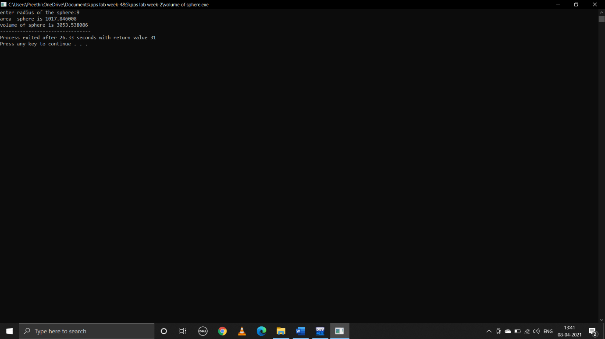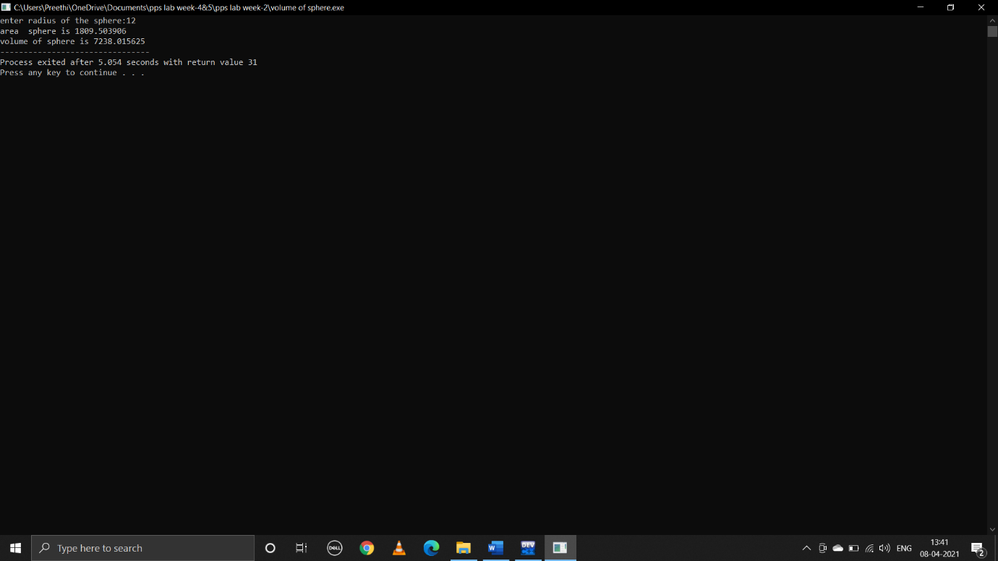

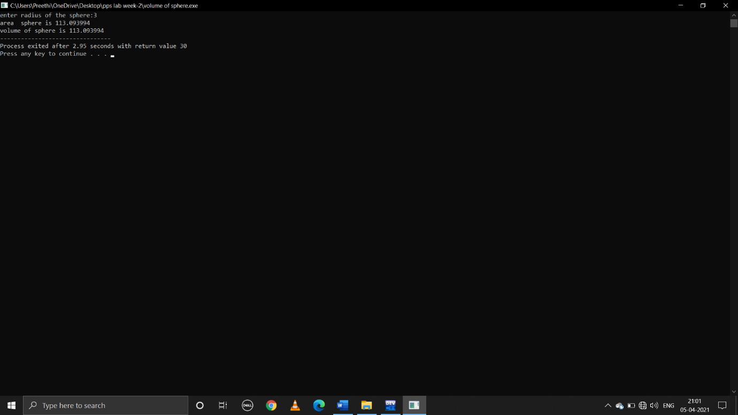

**3.write a C program to convert centigrade into farenheit.**

**Formula:c=(F-32)/1.8**

**Pseudocode:**

Start

Declare float c,f

Take user input temperature in celusis

To convert input temperature into farenheit use formula

f=(c*1.8)+32

print f

end

**C program:**

#include<stdio.h>

void main()

{

float c,f;

printf("enter temperature in celusis:");

scanf("%f",&c);

f=(c*1.8)+32;

printf("temperature in fareinheit is:%f",f);

}

**Output:**

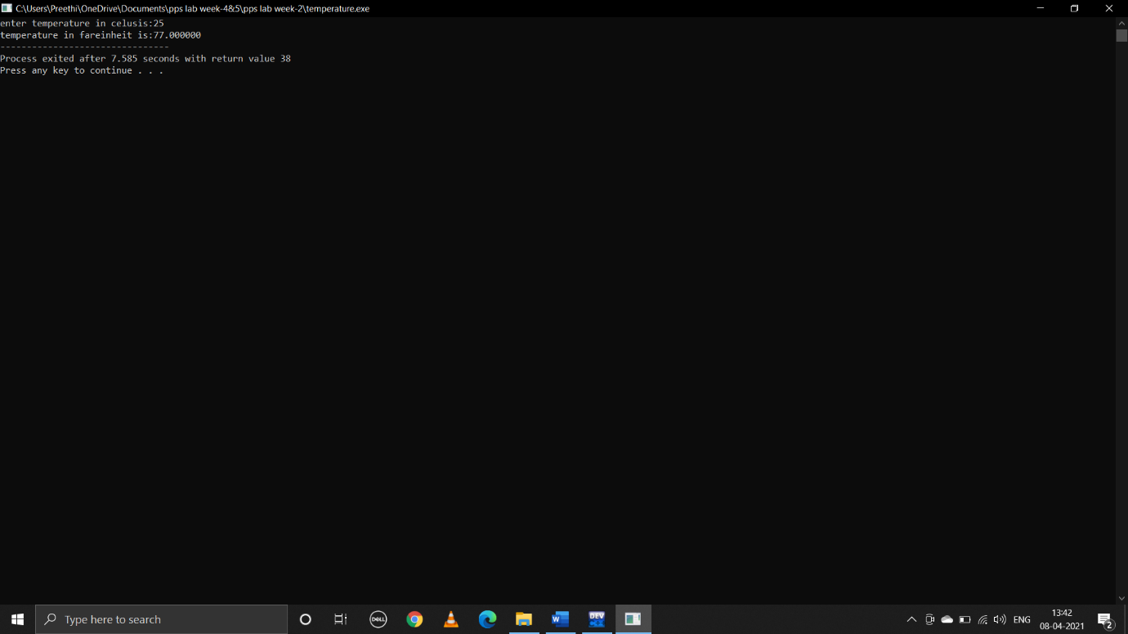

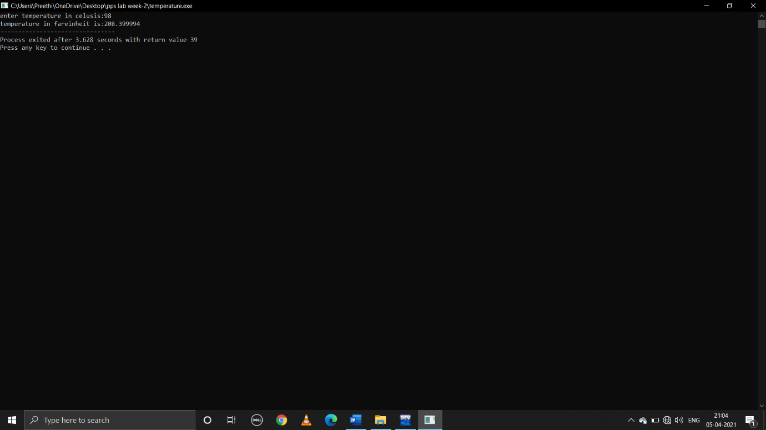

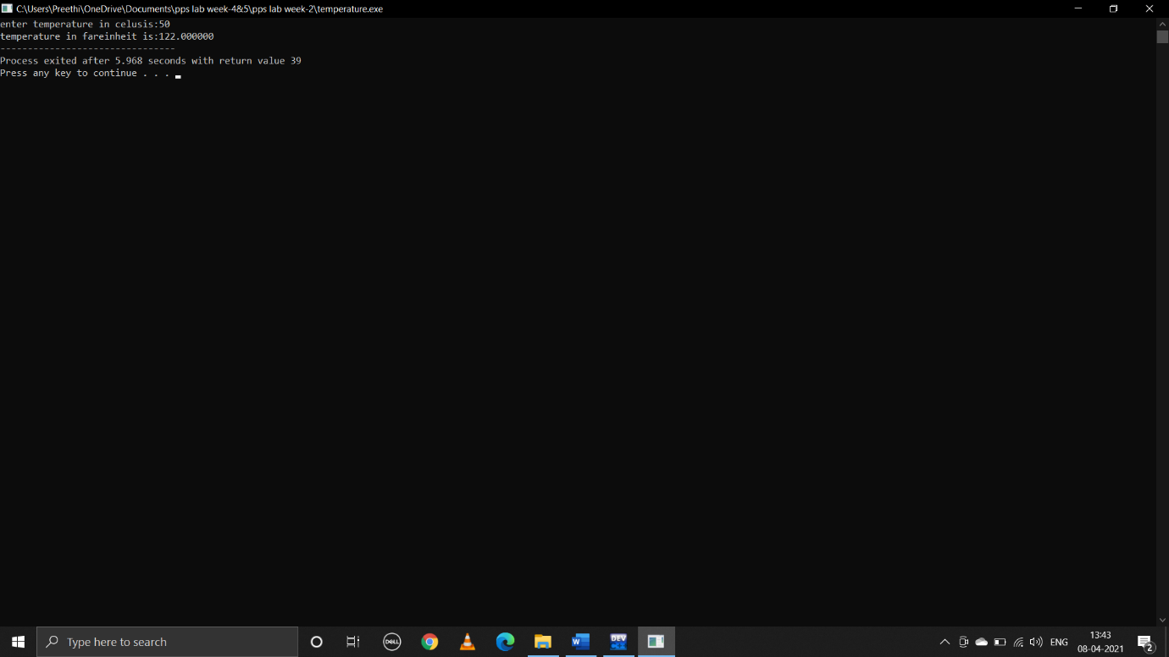

**4.write a C program to read in two integers and display one as a percentage of the other.Typically your output should look like 20 is 50.00% of 40 assuming that the input numbers where 20 and 40 .Display the percentage correct to 2 decimal places.**

**Pseudocode:**

Begin

Declare int a,b

Float c

Take user input two integers a and b

If(a<b)

C=(100*a)/b

To print exactly two decimal places specify two decimals i,e:%.2f%

Print c

else if(b<a)

c=(100*b)/a

print c

else print equal

end

**C program:**

#include<stdio.h>

void main()

{

int a,b;

float c;

printf("enter a:");

scanf("%d",&a);

printf("enter b:");

scanf("%d",&b);

if(a<b)

{

c=(100*a)/b;

printf("%d is %.2f%% of %d",a,c,b);

}

else if(a>b)

{

c=(100*b)/a;

printf("%d is %.2f%% of %d",b,c,a);

}

else

{

printf("both are equal");

}

}

**Output:**

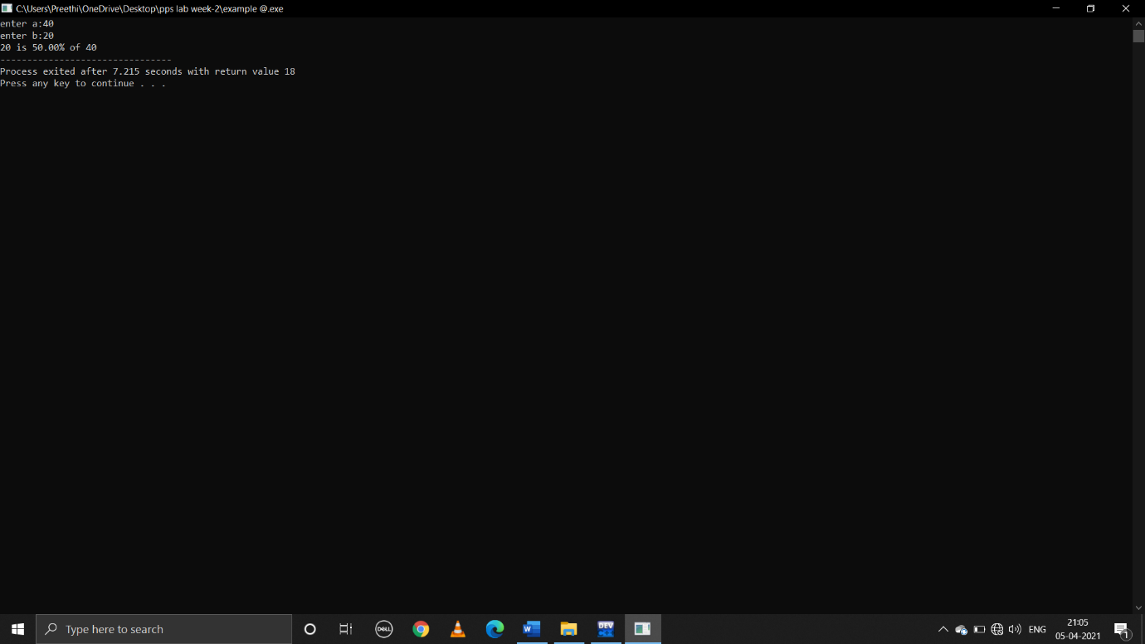

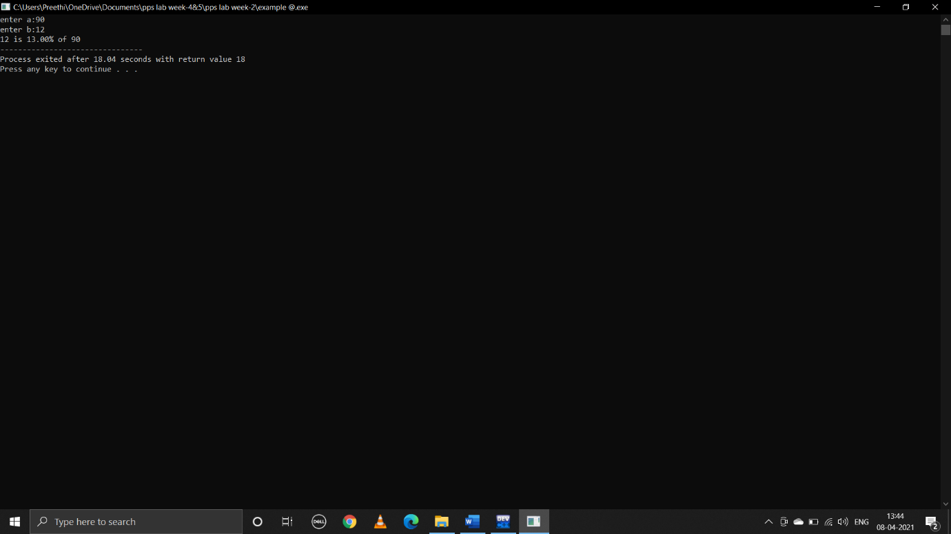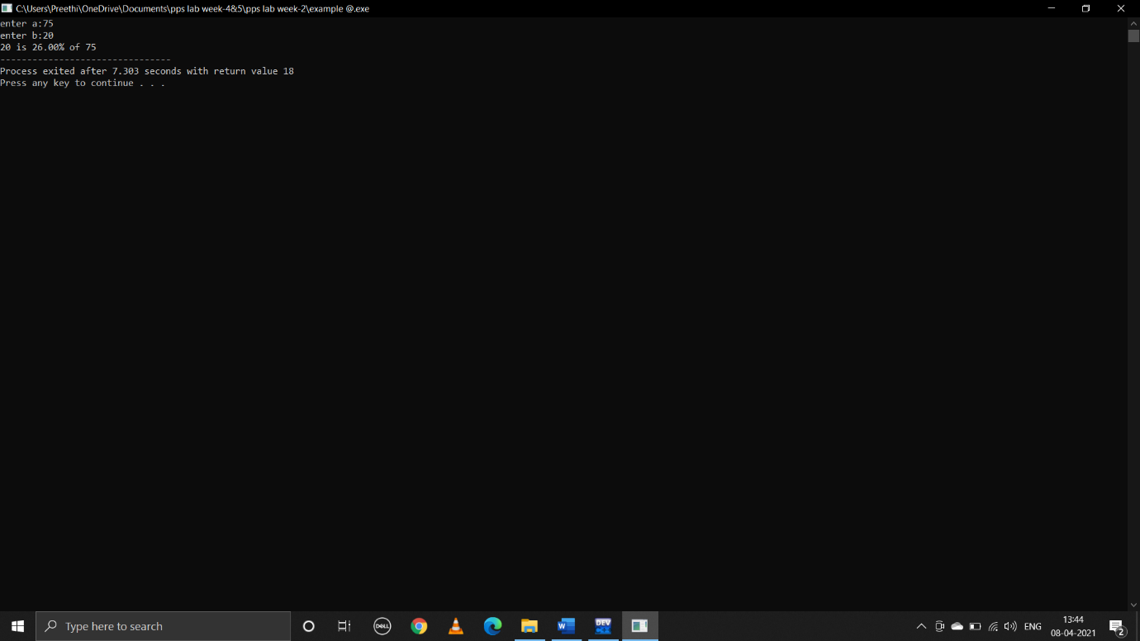

**WEEK-3**

**1.write a C program to find the maximum from given three nos.**

**Pseudocode:**

Begin

Declare int a,b,c

Take user input values of a,b and c

if((a>b)&&(a>c))

Print a is greater

else if((b>a)&&(b>c))

print b is greater

else print c is greater

**C program:**

#include<stdio.h>

void main()

{

int a,b,c;

printf("enter a,b,c values:");

scanf("%d%d%d",&a,&b,&c);

if((a>b)&&(a>c))

{

printf("%d is greater",a);

}

else if((b>a)&&(b>c))

{

printf("%d is greater",b);

}

else

{

printf("%d is greater",c);

}

}

**Output:**

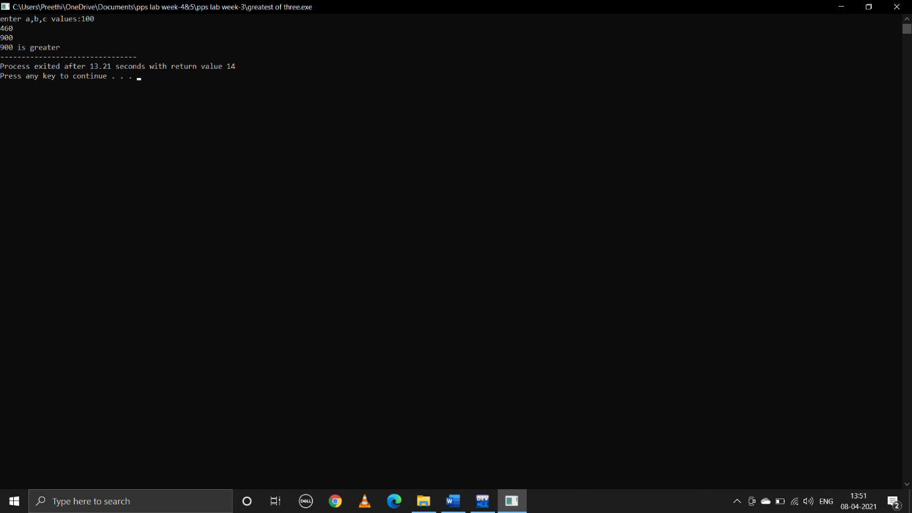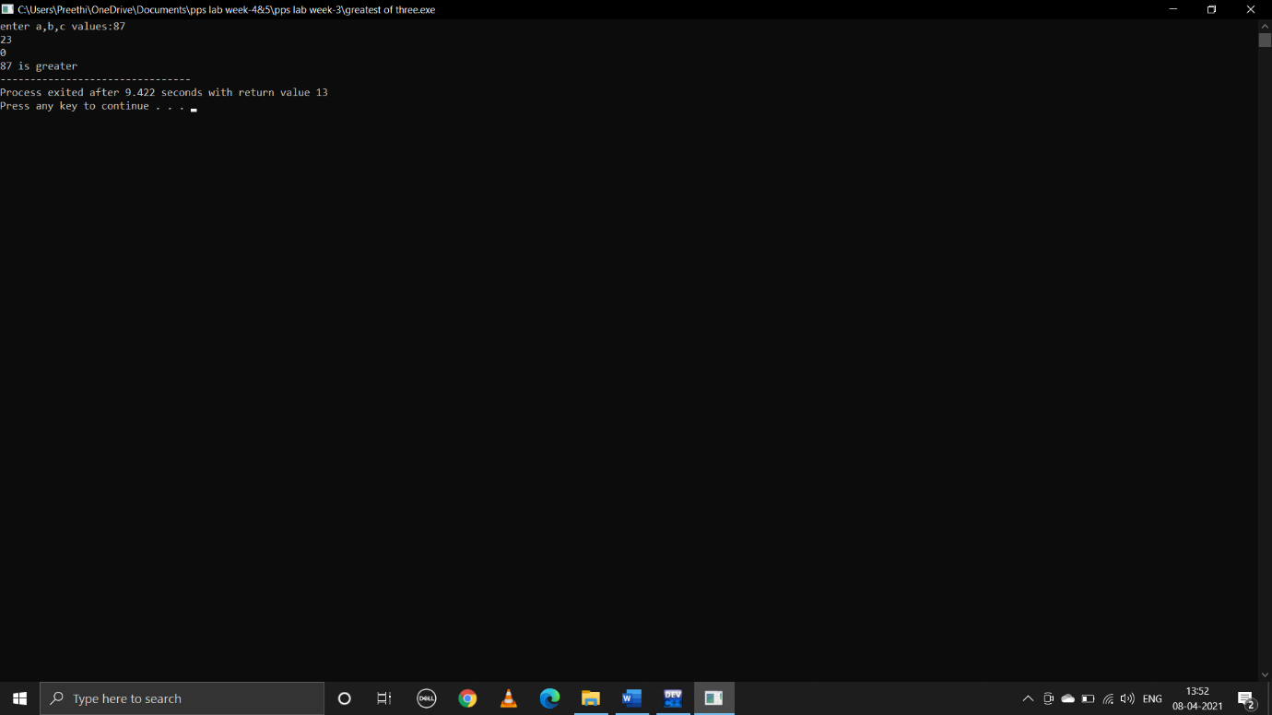

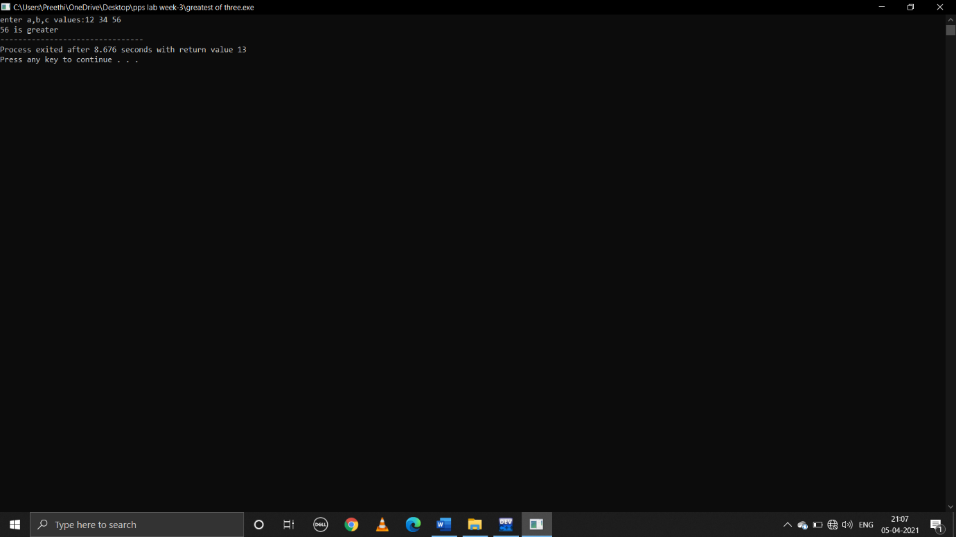

**2.write a C program to find that the accepted no is negative,positive or zero.**

**Pseudocode:**

Begin

Declare int a

Take user input value of a

if(a>0)

print positive

else if(a<0)

print negative

else print 0

end

**C program:**

#include<stdio.h>

void main()

{

int a;

printf("enter a value:");

scanf("%d",&a);

if(a>0)

{

printf("positive");

}

else if(a<0)

{

printf("negative");

}

else

{

printf("0");

}

}

**Ouput:**

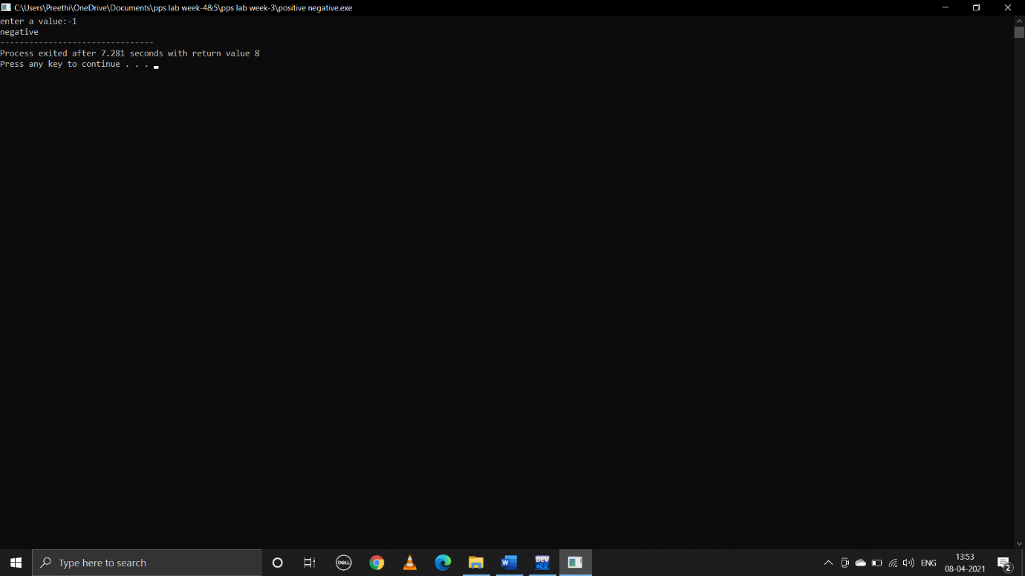

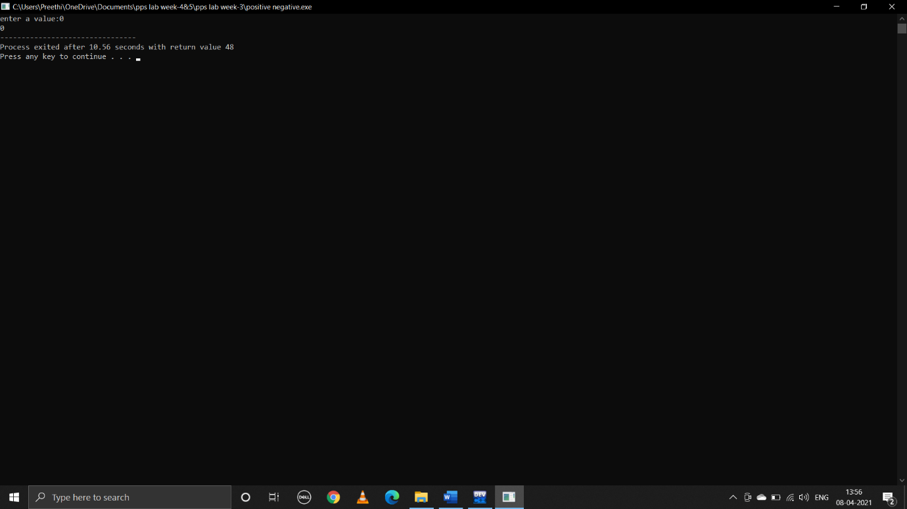

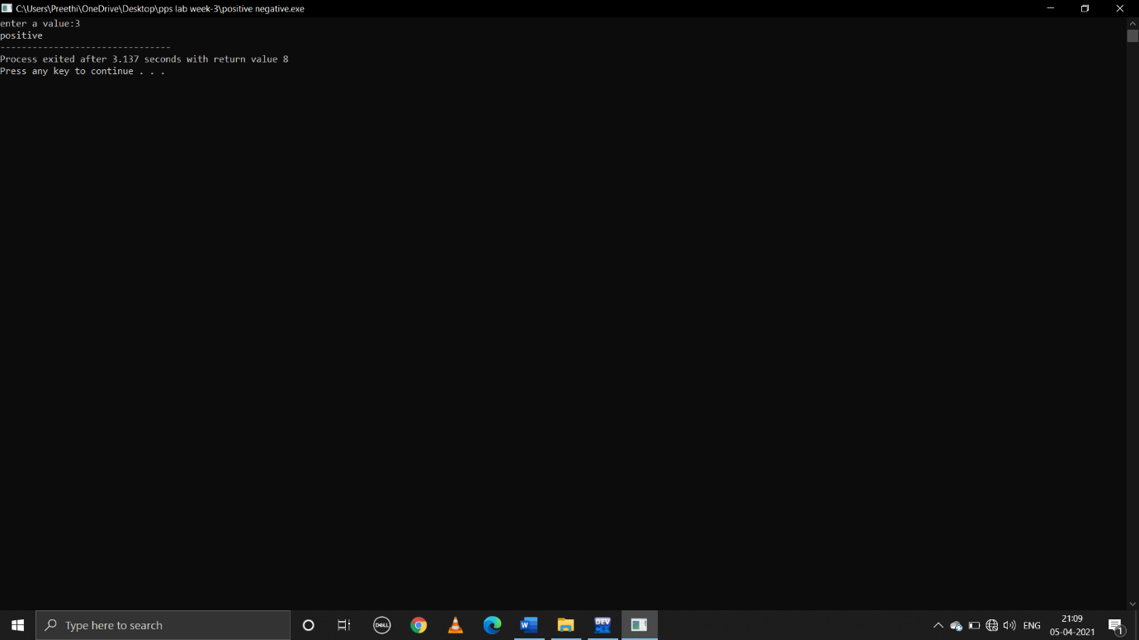

**3.write a program which reads two integer values.If the first is lesser print the message “up”.If the second is lesser,print the message “down”if they are equal,print the message “equal” if there is an error reading the data,print a message containing the word “Error”.**

**Pseudocode:**

Begin

Declare int a,b

Take user input values of a and b

if(a<b)

Print up

else if(b<a)

Print down

else if(b==a)

print equal

else print equal

end

**C program:**

#include<stdio.h>

void main()

{

int a,b;

printf("enter a,b values:");

scanf("%d %d",&a ,&b);

if(a<b)

{

printf("up");

}

else if(b<a)

{

printf("down");

}

else if(b==a)

{

printf("equal");

}

else

{

printf("error");

}

}

**Output:**

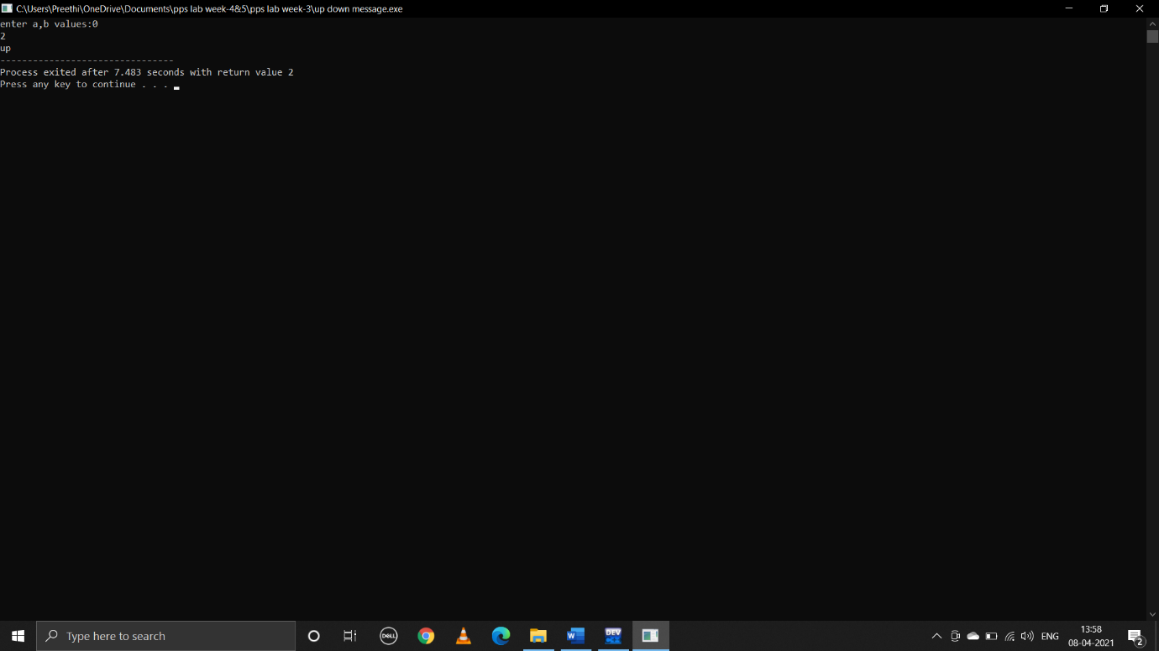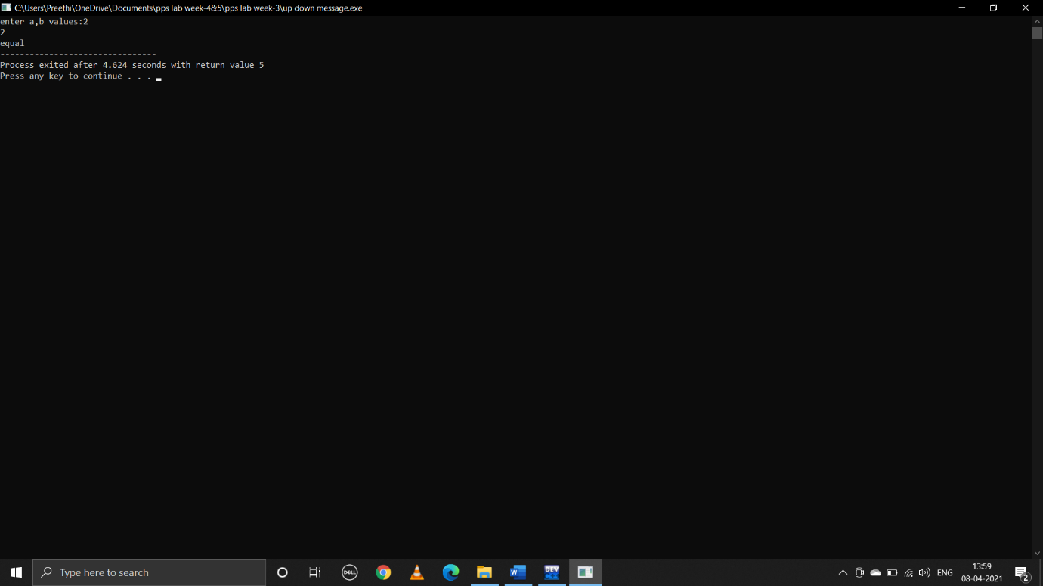

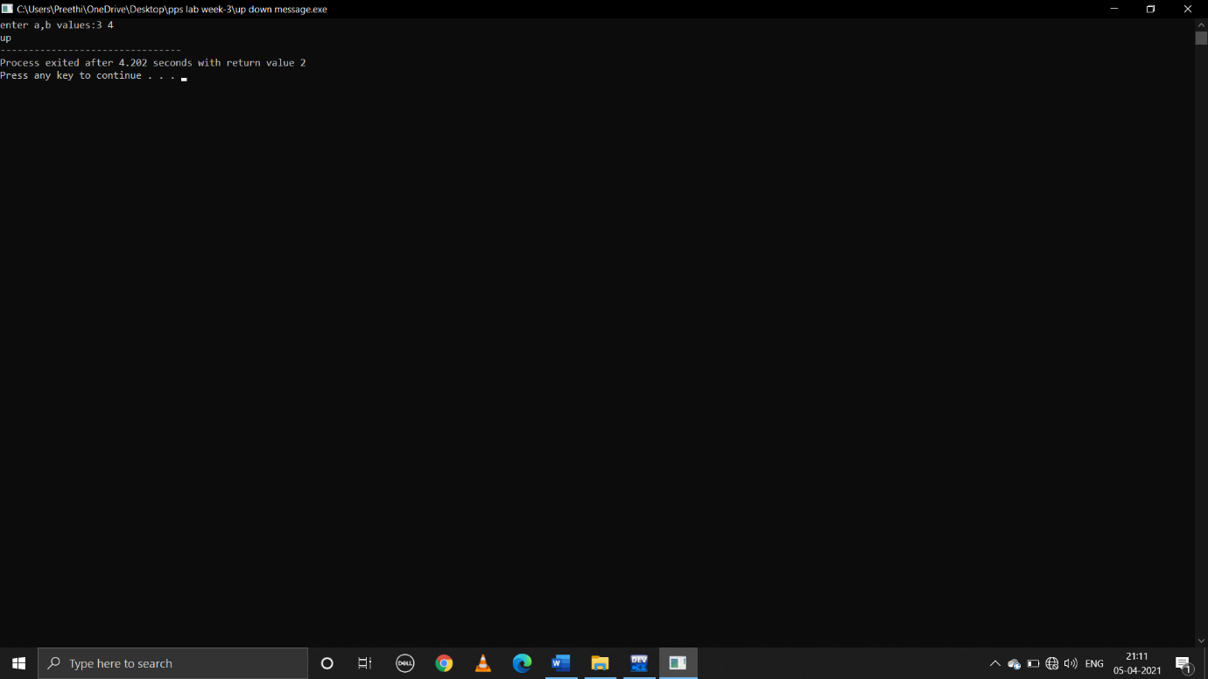

**4.write a C program that prints the given three integers in ascending order using if-else.**

**Pseudocode:**

Begin

Declare int a,b,c

Take user input values of a,b,c

if((a<b)&&(a<c))

{

if(b<c)

print a,b,c

else print a,c,b

}

else if((b<a)&&(b<c))

{

if(a<c)

print b,a,c

else print b,c,a

}

else if((c<a)&&(c<b))

{

if(a<b)

print c,a,b

else print c,b,a

}

End

**C program:**

#include<stdio.h>

void main()

{

int a,b,c;

printf("enter a,b,c values:");

scanf("%d%d%d",&a,&b,&c);

if((a<b)&&(a<c))

{

if(b<c)

{

printf("ascending order is:%d %d %d",a,b,c);

}

else

{

printf("ascending order is :%d %d %d",a,c,b);

}

}

else if((b<a)&&(b<c))

{

if(a<c)

{

printf("ascending order is:%d %d %d",b,a,c);

}

else

{

printf("ascending order is:%d %d %d",b,c,a);

}

}

else if((c<a)&&(c<b))

{

{

printf("ascending order is:%d %d %d",c,a,b);

}

else

{

printf("ascending order is:%d %d %d",c,b,a);

}

}

}

**Output:** 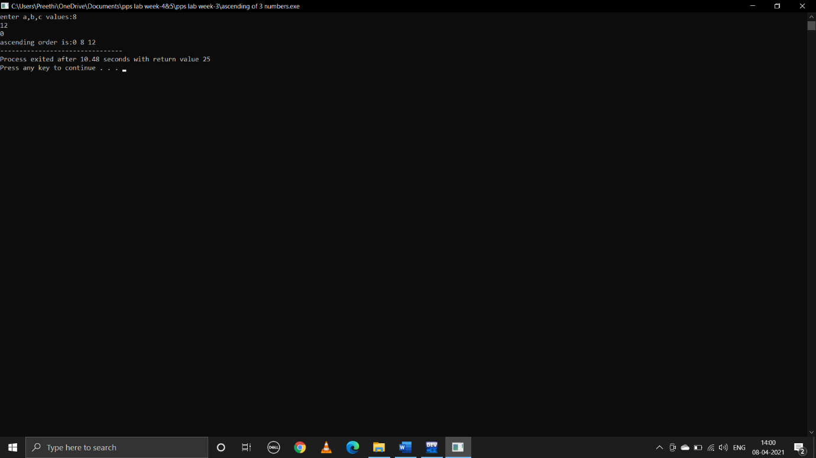

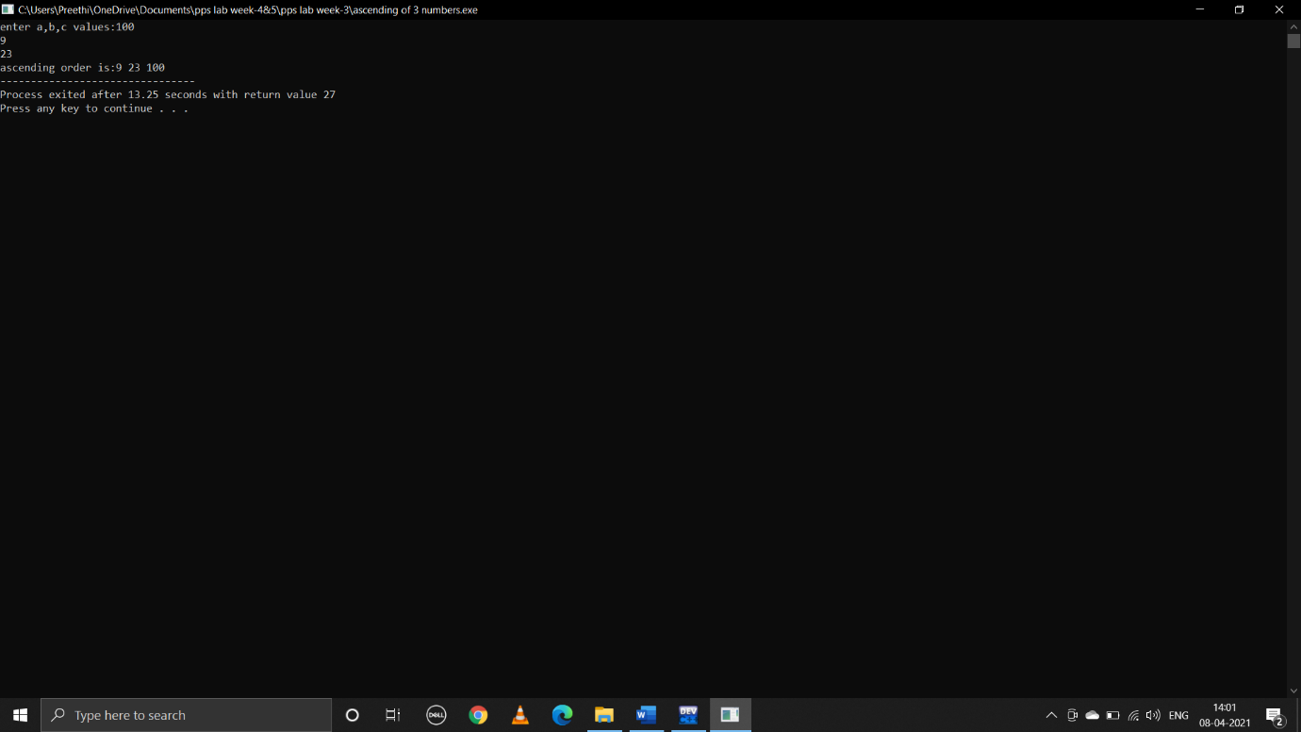

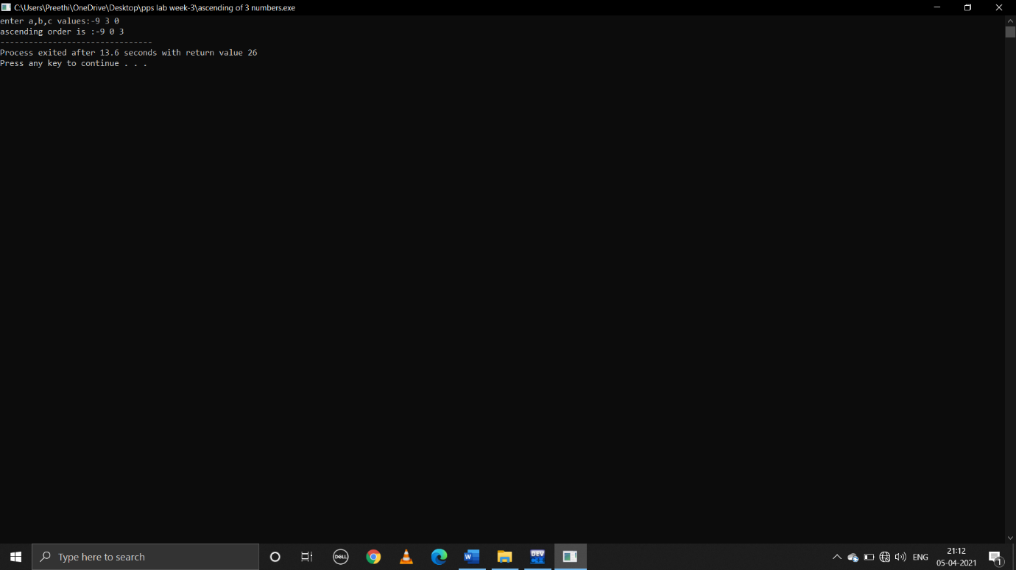

**WEEK-4&5**

**1.write a C program to find the sum of first 100 odd nos. and even nos.**

**Pseudocode:**

Begin

Declare int i,odd=0,even=0

To print sum of first 100 odd numbers

Run for loop from 1 to 200 by increment of 2

odd=odd+i

To print sum of first 100 even numbers

Run for loop from 1 to 200 by increment of 2

even=even+i

print(odd,even)

end

**C program:**

#include<stdio.h>

void main()

{

Int i,odd=0,even=0;

for(i=1;i<=200;i=i+2)

{

even=even+i;

}

for(i=1;i<=200;i=i+2)

{

odd=odd+i;

}

printf("sum of 1st 100 odd numbers:%d\nsum of 1st 100 even numbers:%d\n",odd,even);

}

**Output:**

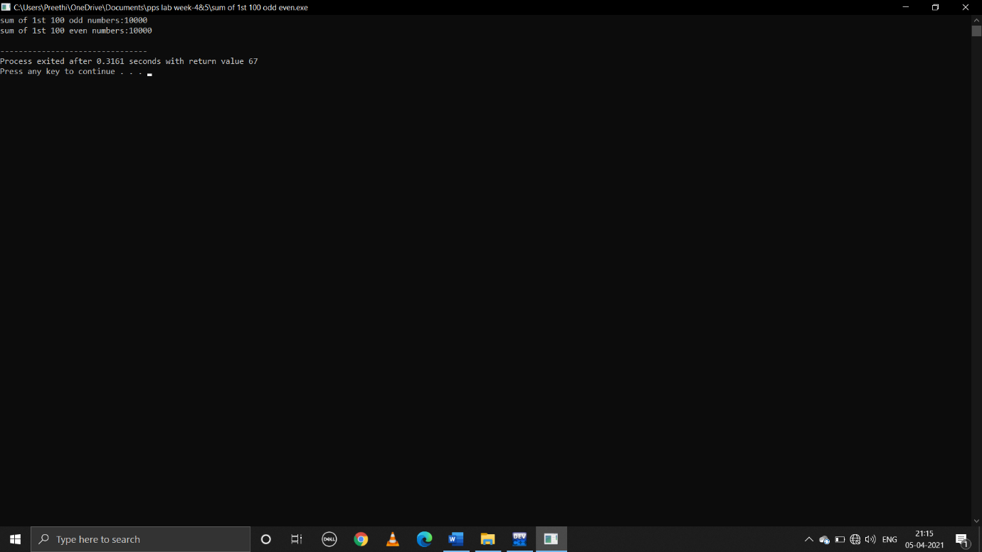

**2.write a C program to display first 100 prime nos.**

**Pseudocode:**

Begin

Declare int n,i=3,count,c

Take user input n to print the number of prime numbers required

if(n>=1)

print 2 which is a first prime number

run for loop from count=2 to count<=n by increment of i=i+1

for(c=2;c<i;c++)

if(i%c==0)

break

if(c==i)

print i

count ++

end

**C program:**

#include<stdio.h>

void main()

{

int n,i=3,count,c;

printf("enter the number of prime numbers required:");

scanf("%d",&n);

if(n>=1)

{

printf("first %d prime numbers are:",n);

printf("2 ");

}

for(count=2;count<=n;i++)

{

for(c=2;c<i;c++)

{

if(i%c==0)

break;

}

if(c==i)

{

printf("%d ",i);

count++;

}

}

}

**Output:**

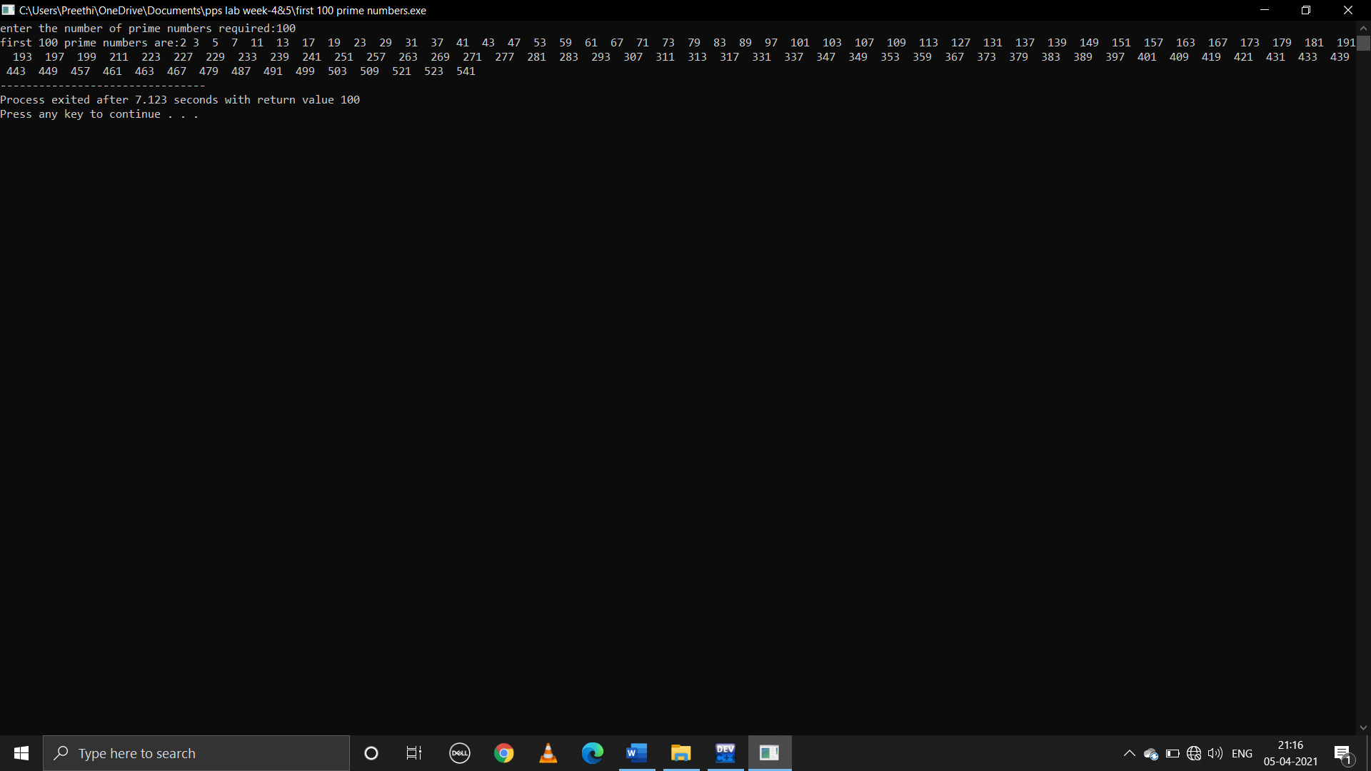

**3.write a C program to read in a three digit number produce following ouput (Assuming that the input is 347) 3 hundreds,4 tens,7 units**

**Pseudocode:**

Begin

Declare int n,u,t

Take user input n of 3 digit number

To print last digit of number u=n%10

n=n/10 to print first two digits

to print second last digit of number t=n%10

to print first digit

n=n/10

print(n,t,u)

end

**C program:**

#include<stdio.h>

void main()

{

int n,u,t;

printf("enter 3 digit number:\n");

scanf("%d",&n);

u=n%10;

n=n/10;

t=n%10;

n=n/10;

printf("%d hundreds %d tens %d units",n,t,u);

}

**Output:**

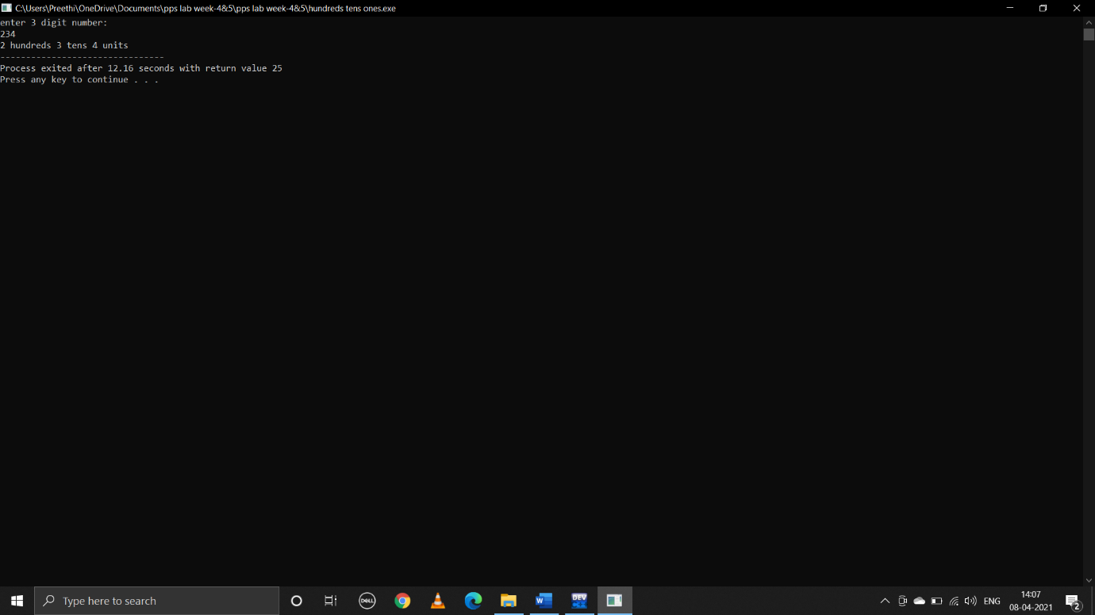

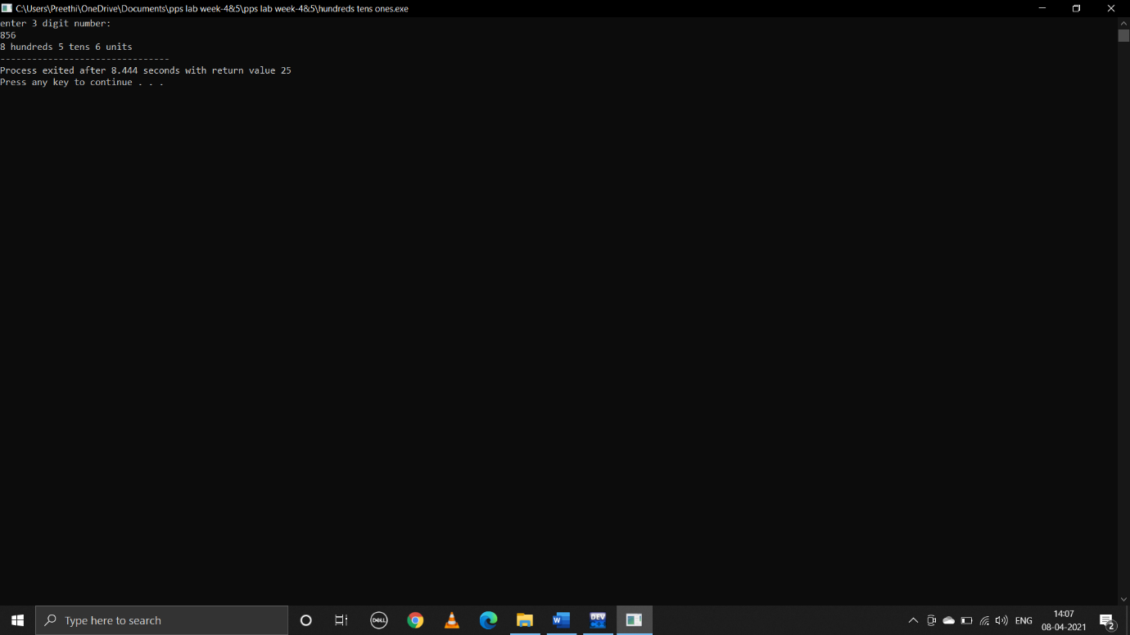

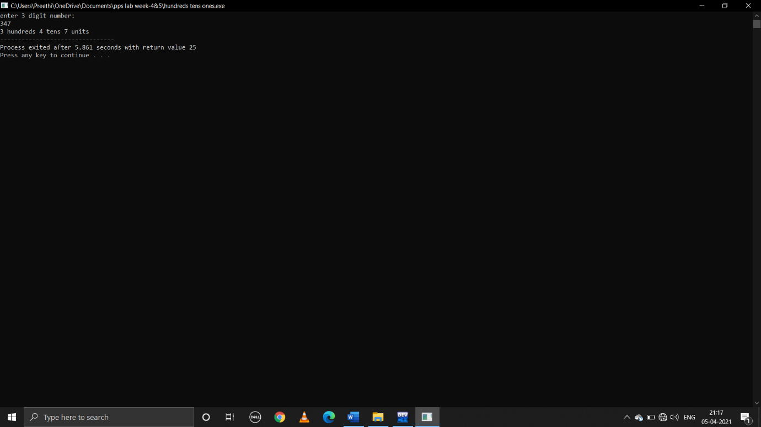

**4.write a C program to display Fibonacci series**

**Pseudocode:**

Begin

Declare int n,i,nth,n1=0,n2=1

Take user input n to print number of terms

Print n1,n2

Run loop from i=0 to i=n-2 by increment of i=i+1

nth=n1+n2

print nth

update n1=n2,n2=nth

end

**C program:**

#include<stdio.h>

int main()

{

int n,i;

int nth;

int n1=0;

int n2=1;

printf("enter n:");

scanf("%d",&n);

printf("%d\n%d\n",n1,n2);

for(i=0;i<n-2;i++)

{

nth=n1+n2;

printf("%d\n",nth);

n1=n2;

n2=nth;

}

return 0;

}

**Output:**

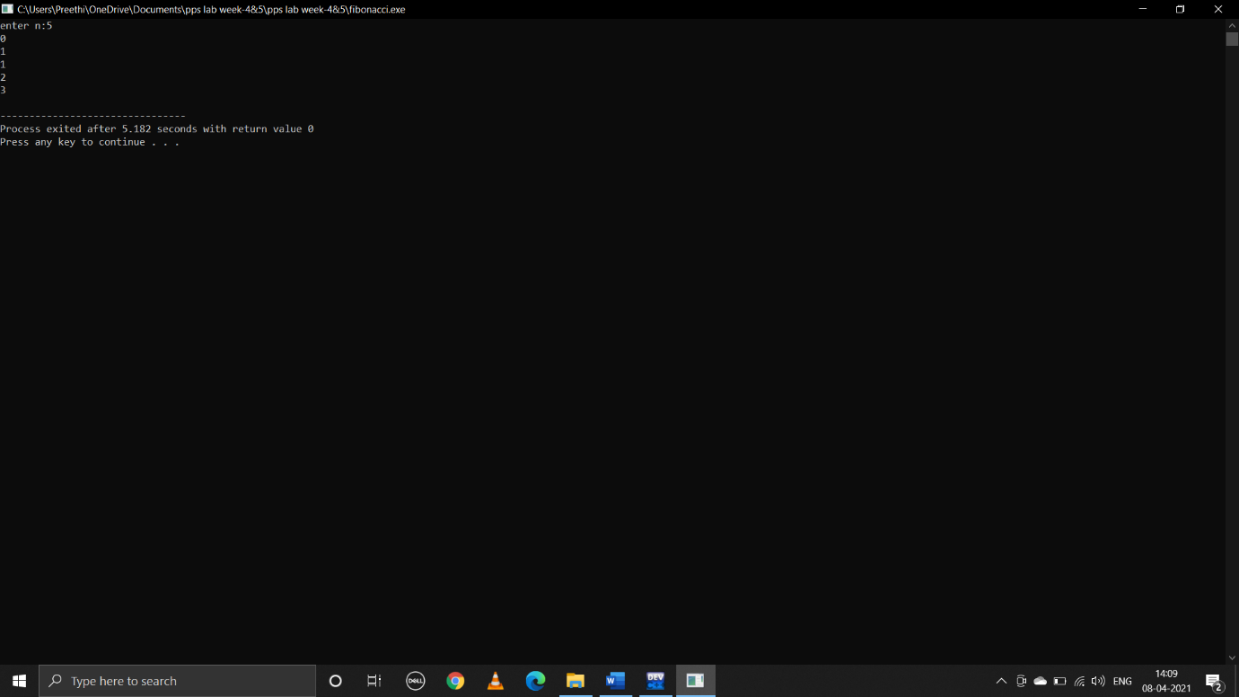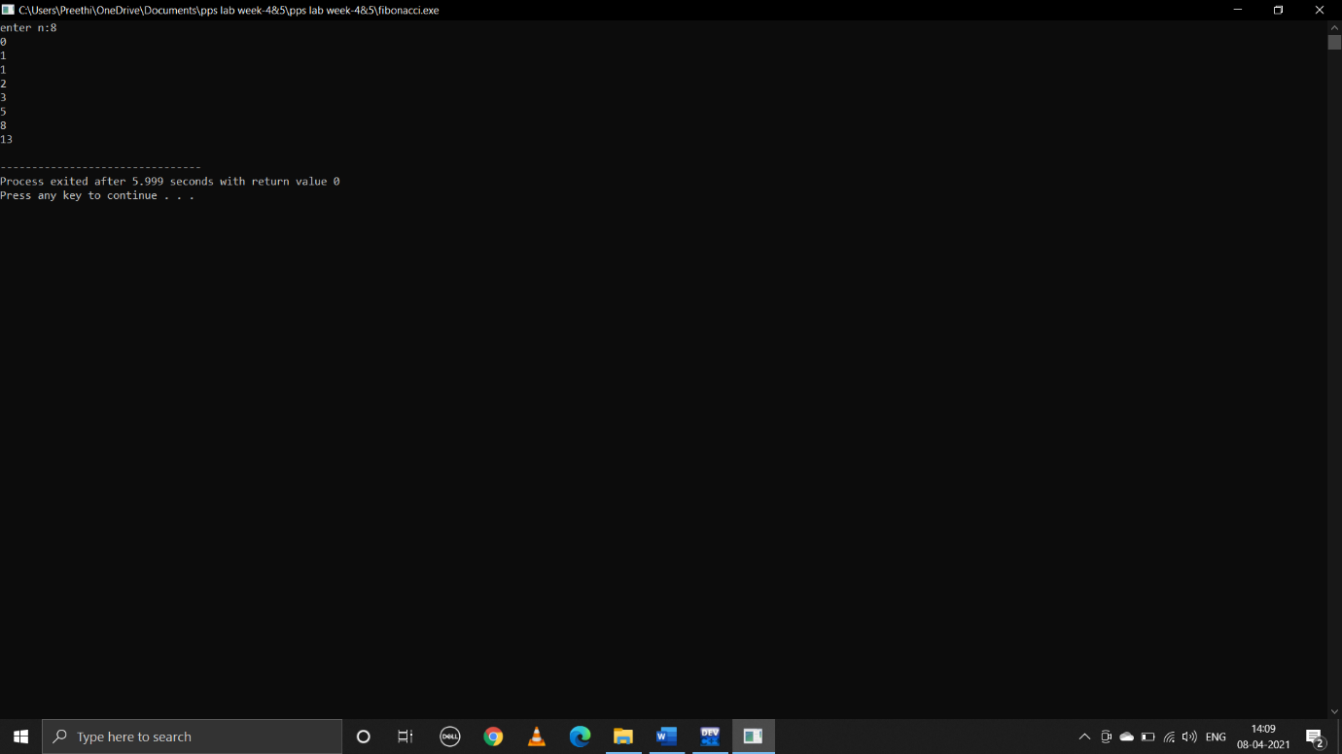

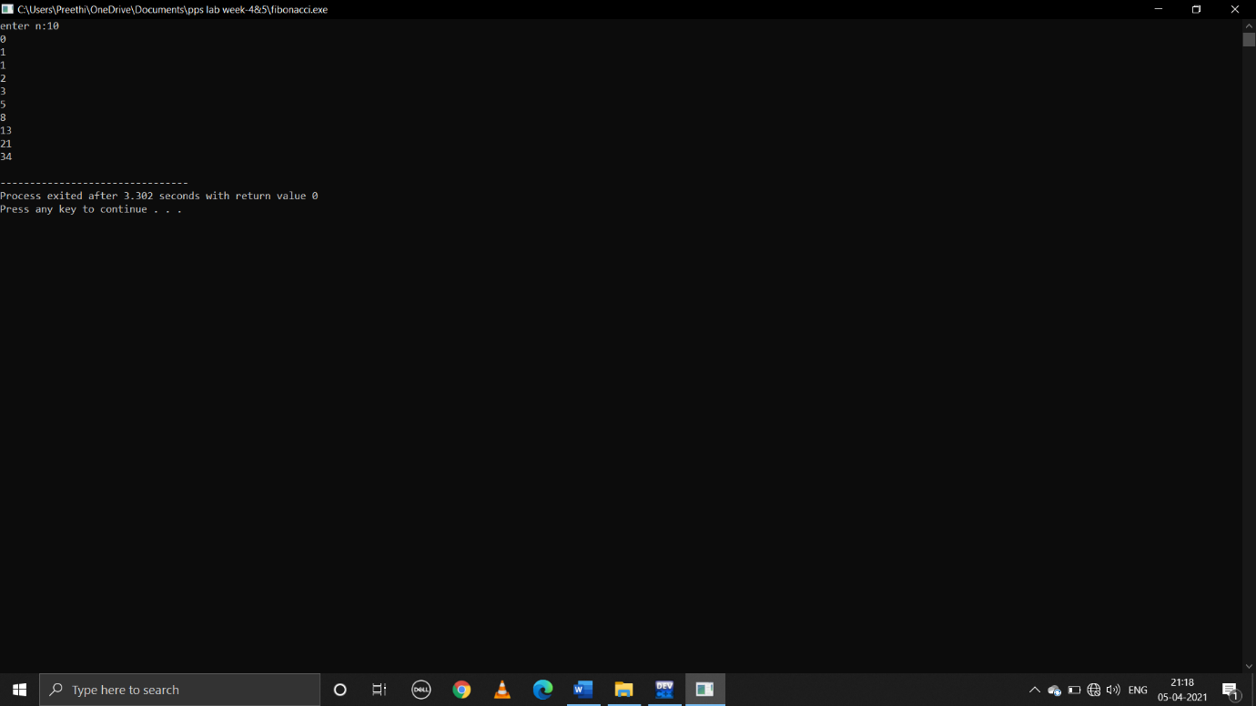

**5.write a C program to calculate the following**

**i.sum=1-x2/2!+x4/4!-x6/6!+x8/8!-x10/10!+……..,**

**pseudocode:**

begin

declare int n,x,p,fact,i,sign=-1

float sum=1.0

take user input n value of number of terms

take user input value of x

run loop from p=2 to p<=n by increment of p by 2

fact=1

to get factorial run loop from i=1 to i<=p by increment of i by 1

fact=fact*i

sum=sum+(sign*(pow(x,p))/fact)

sign=sign*-1

print sum

end

**C program:**

#include<stdio.h>

#include<math.h>

void main()

{

int n,x,p,fact,i,sign=-1;

float sum=1.0;

printf("enter n value:");

scanf("%d",&n);

printf("enter x value:");

scanf("%d",&x);

for(p=2;p<=n;p=p+2)

{

fact=1;

for(i=1;i<=p;i++)

{

fact=fact*i;

}

sum=sum+(sign*(pow(x,p))/fact);

sign=sign*-1;

}

printf("the value of series is %f",sum);

}

**Output:**

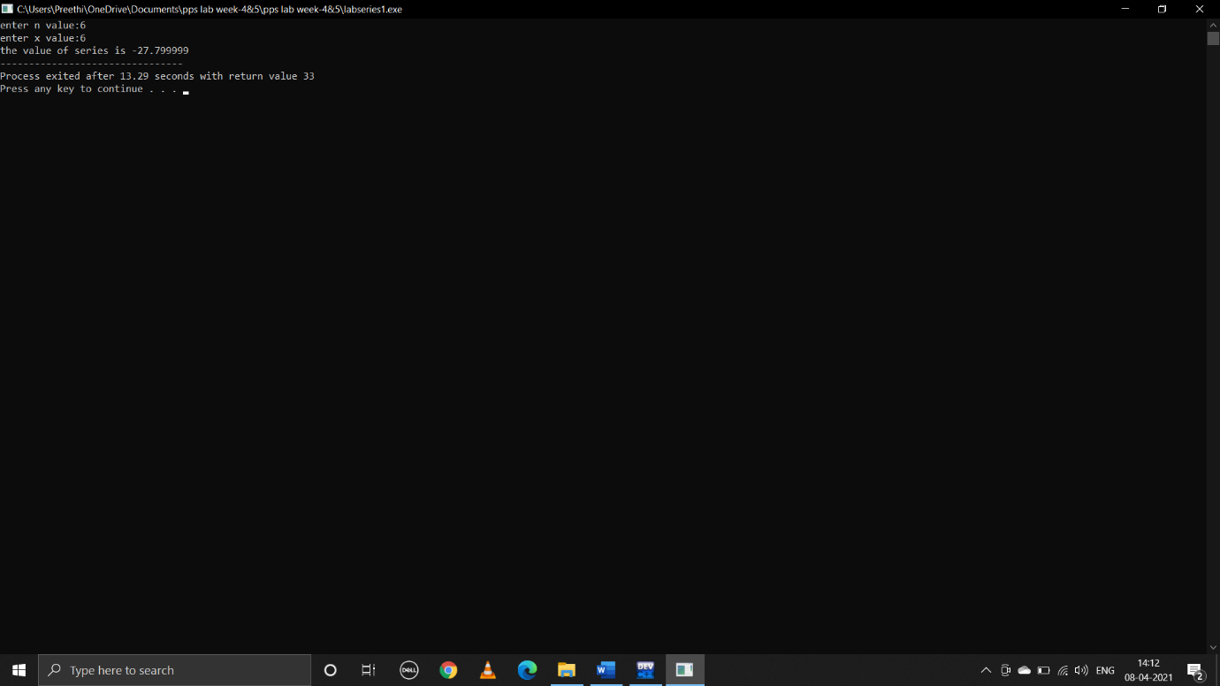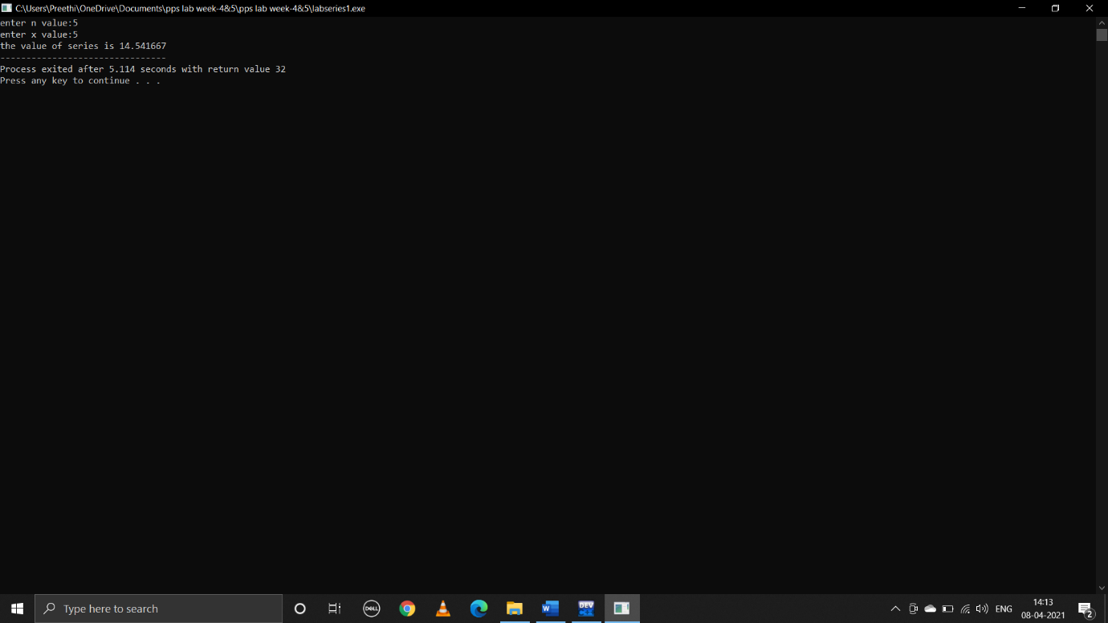

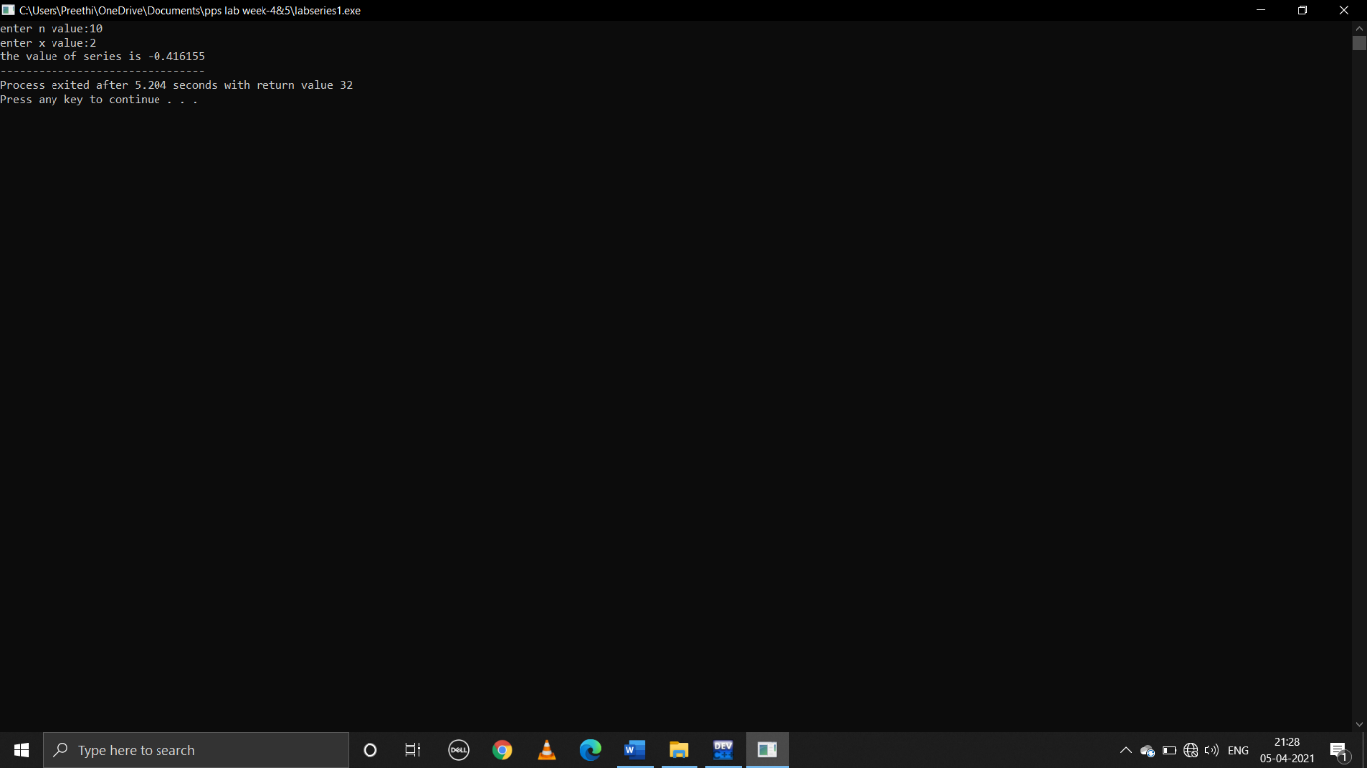

**ii.sum=x-x3/3!+x5/5!..............,**

**pseudocode:**

begin

declare int n,x,p,fact,I,sign=-1

float sum=0.0

take user input value of n for number of terms

take user input value of x

run loop from p=1 to p<=n by increment of p=p+2

fact=1

to get factorial run loop from i=1 to i<=p by increment i=i+1

fact=fact*i

sign=sign*-1

sum=sum+(sign*(pow(x,p))/fact)

print sum

end

**C program:**

#include<stdio.h>

#include<math.h>

void main()

{

int n,x,p,fact,i,sign=-1;

float sum=0.0;

printf("enter n value:");

scanf("%d",&n);

printf("enter x value:");

scanf("%d",&x);

for(p=1;p<=n;p=p+2)

{

fact=1;

for(i=1;i<=p;i++)

{

fact=fact*i;

}

sign=sign*-1;

sum=sum+(sign*(pow(x,p))/fact);

}

printf("the value of series is %f",sum);

}

**Output:**

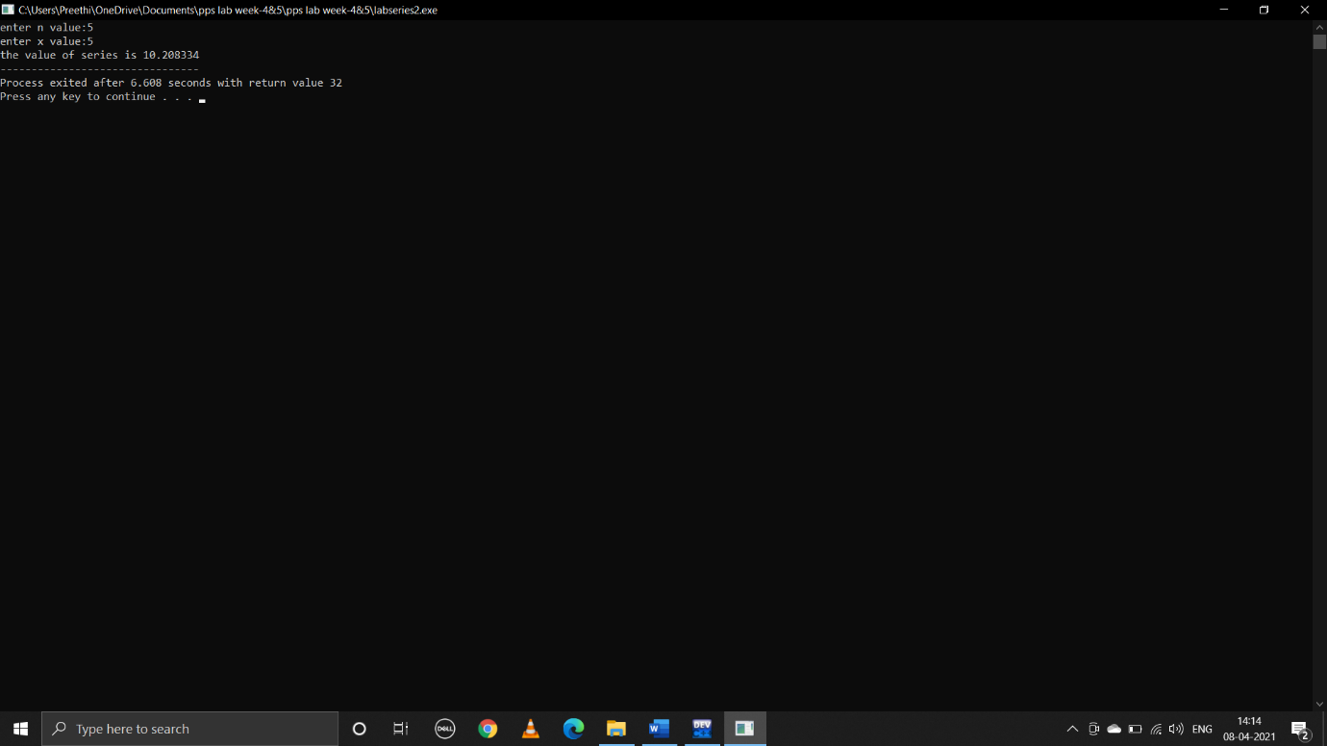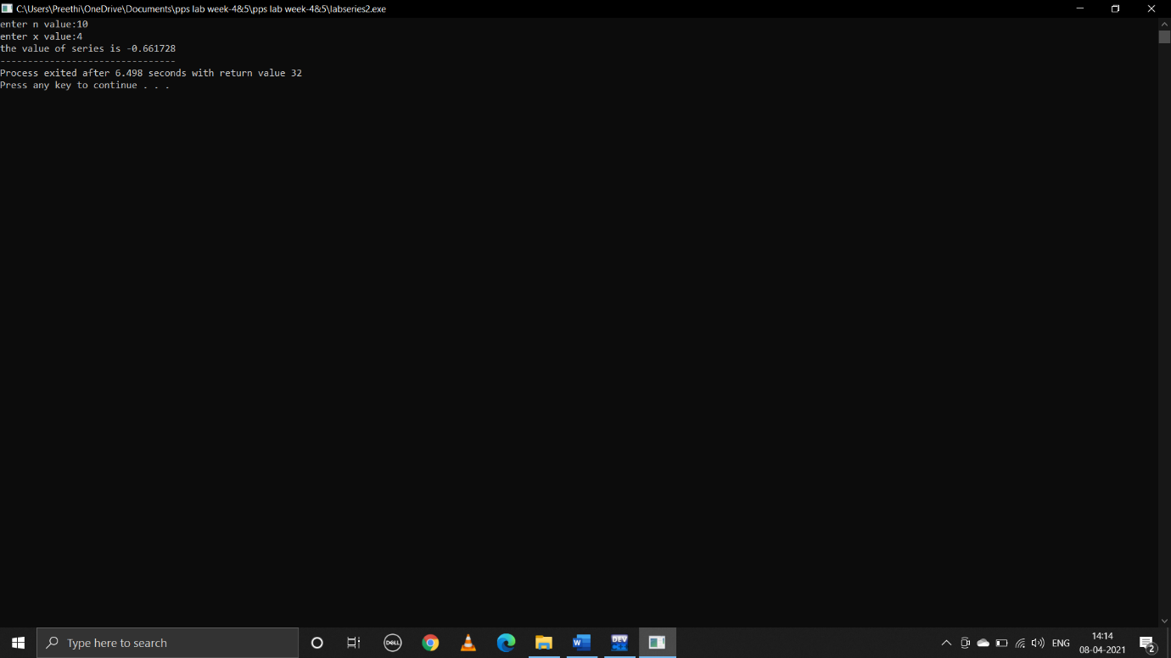

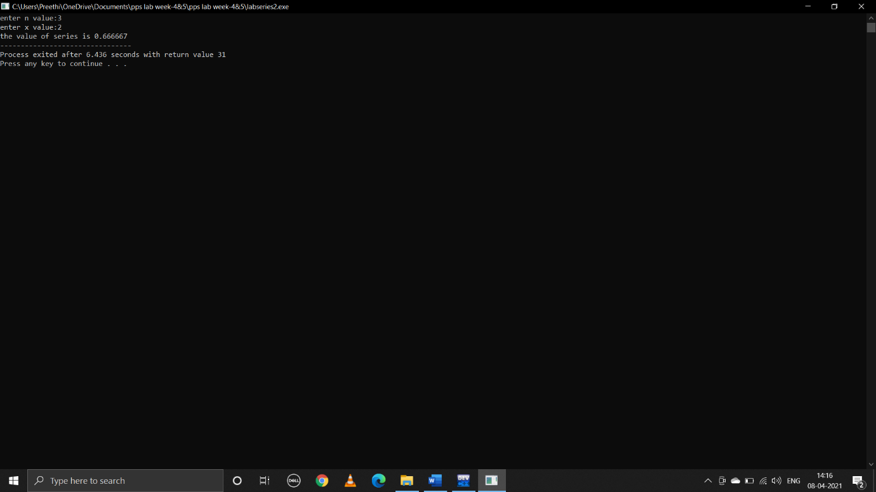

**iii.sum=1+x/1!+x^2/2!+x^3/3!............,**

**pseudocode:**

begin

declare int n,x,p,fact,i,sign=1

run loop from p=1 to p<=n by increment p=p+1

fact=1

to get a factorial run loop from i=1 to i<=p

fact=fact*i

sum=sum+(sign*(pow(x,p))/fact)

print sum

end

**C program:**

#include<stdio.h>

#include<math.h>

void main()

{

int n,x,p,fact,i,sign=1;

float sum=1.0;

printf("enter n value:");

scanf("%d",&n);

printf("enter x value:");

scanf("%d",&x);

for(p=1;p<n;p++)

fact=1;

for(i=1;i<=p;i++)

{

fact=fact*i;

}

sum=sum+(sign*(pow(x,p))/fact);

}

printf("the value of series is %f",sum);

}

**Output:**

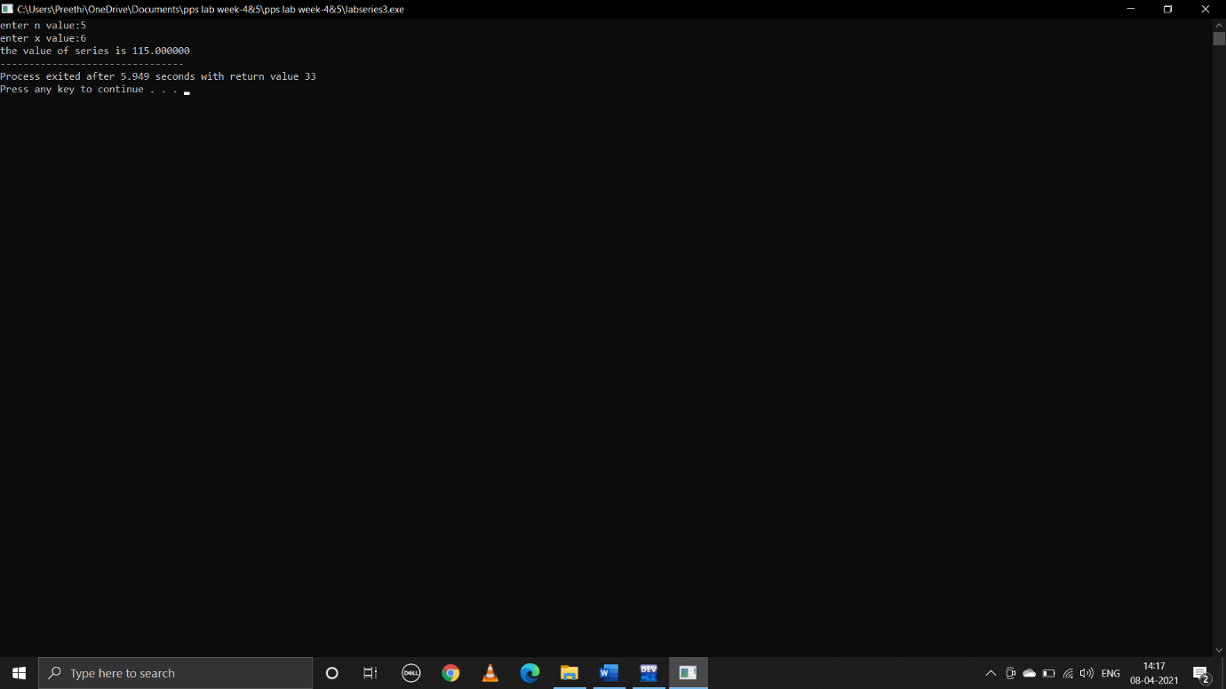

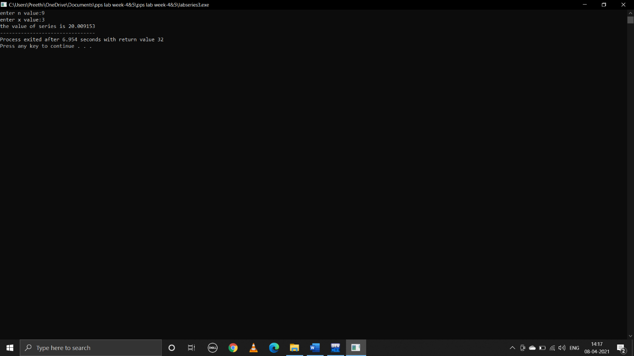

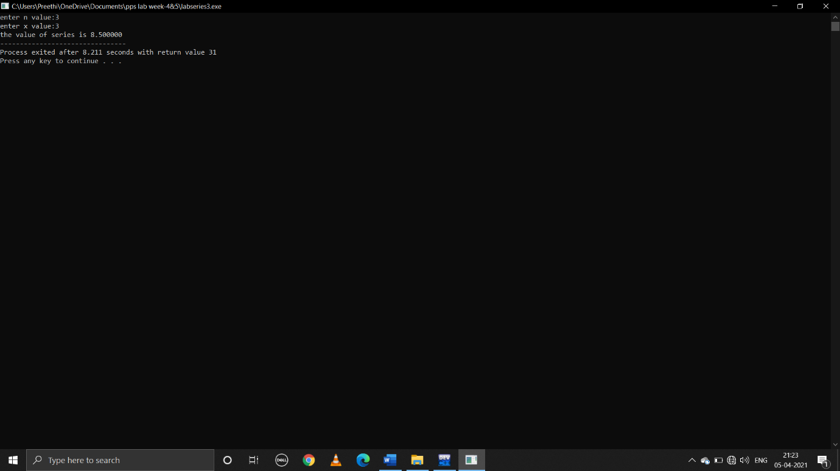

**6.write a C program to find the roots of a quadratic equation.**

**Pseudocode:**

Begin

Declare float=a,b,c,d,imaginary,root1,root2

Take user input values of a,b,c

To find discriminant

d=b*b-4*a*c

if d is positive real distinct roots

root1=-b+sqrt d/2*a

root2=-b-sqrt d/2*a

print(root1,root2)

if d is negative imaginary roots

root1=root2=-b/2*a

imaginary=sqrt(-d)/2*a

print(root1+ imaginary,root1-imaginary)

if d==0 two equal roots

root1=root2=-b/2*a

print(root1,root1)

end

**C program:**

#include<stdio.h>

#include<math.h>

void main()

{

float a,b,c,d,imaginary;

float root1,root2;

printf("enter a,b,c values:");

scanf("%f%f%f",&a,&b,&c);

d=b*b-4*a*c;

if(d>0)

{

root1=(-b+sqrt(d))/(2*a);

root2=(-b-sqrt(d))/(2*a);

printf(" two distinct real roots of quadratic eqn are:%.2f\n %.2f\n",root1,root2);

}

else if(d<0)

{

root1=root2=-b/(2*a);

imaginary=sqrt(-d)/(2*a);

printf(" two distinct imaginary roots of quadratic eqn are:%.2f+i%.2f\n %.2f-i%.2f\n",root1, imaginary,root2,imaginary);

}

else if(d==0)

{

root1=(-b)/(2*a);

root1=root2;

printf("two equal real roots of the quadratic eqn are:%.2f\n %.2f\n",root1,root2);

}

}

**Output:**

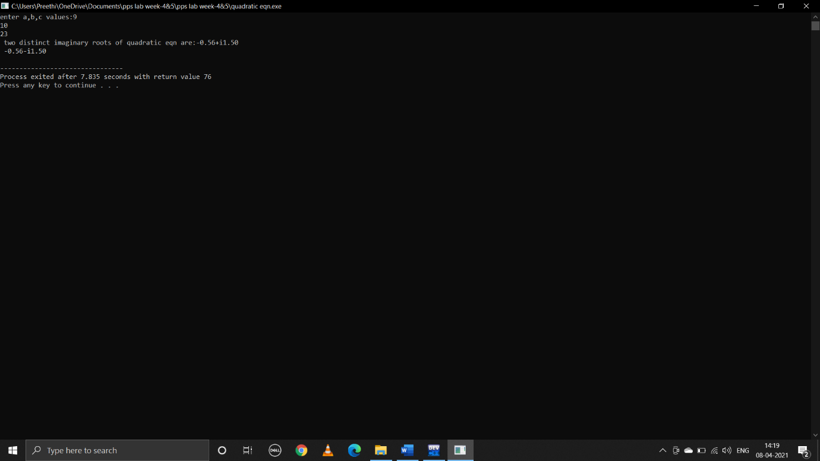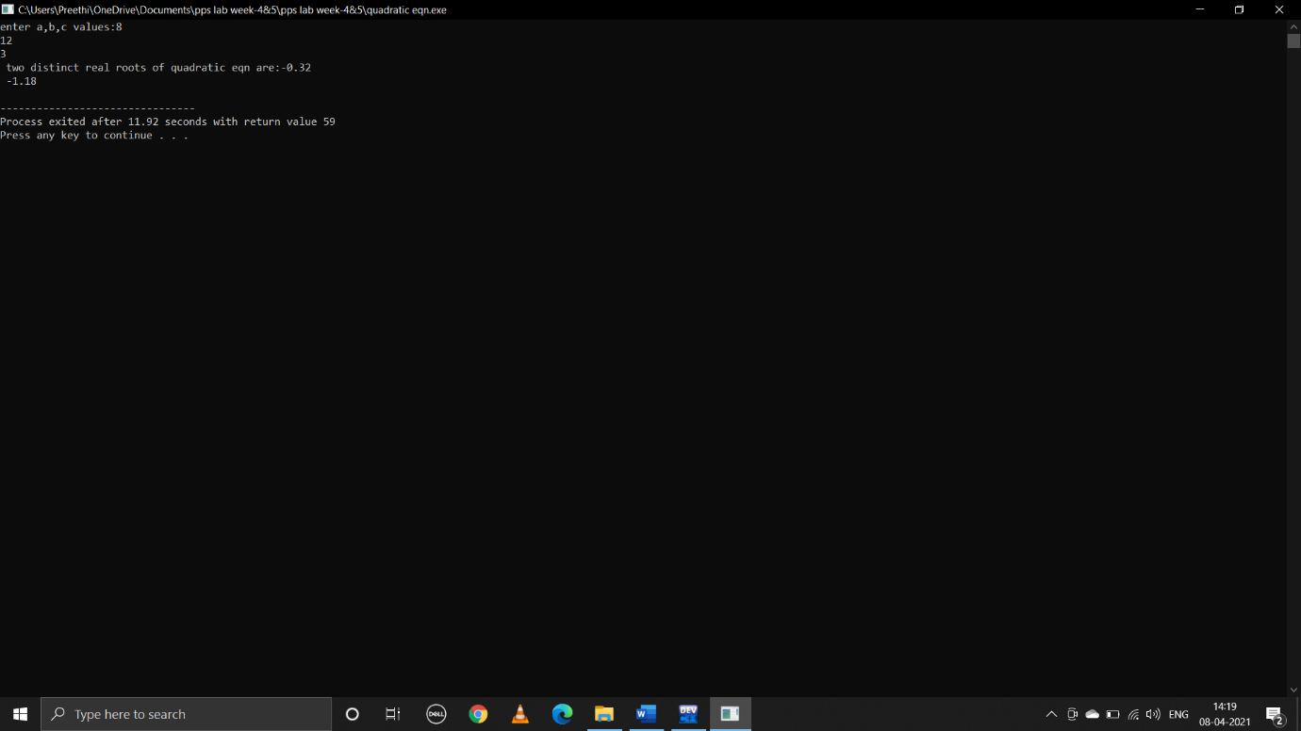

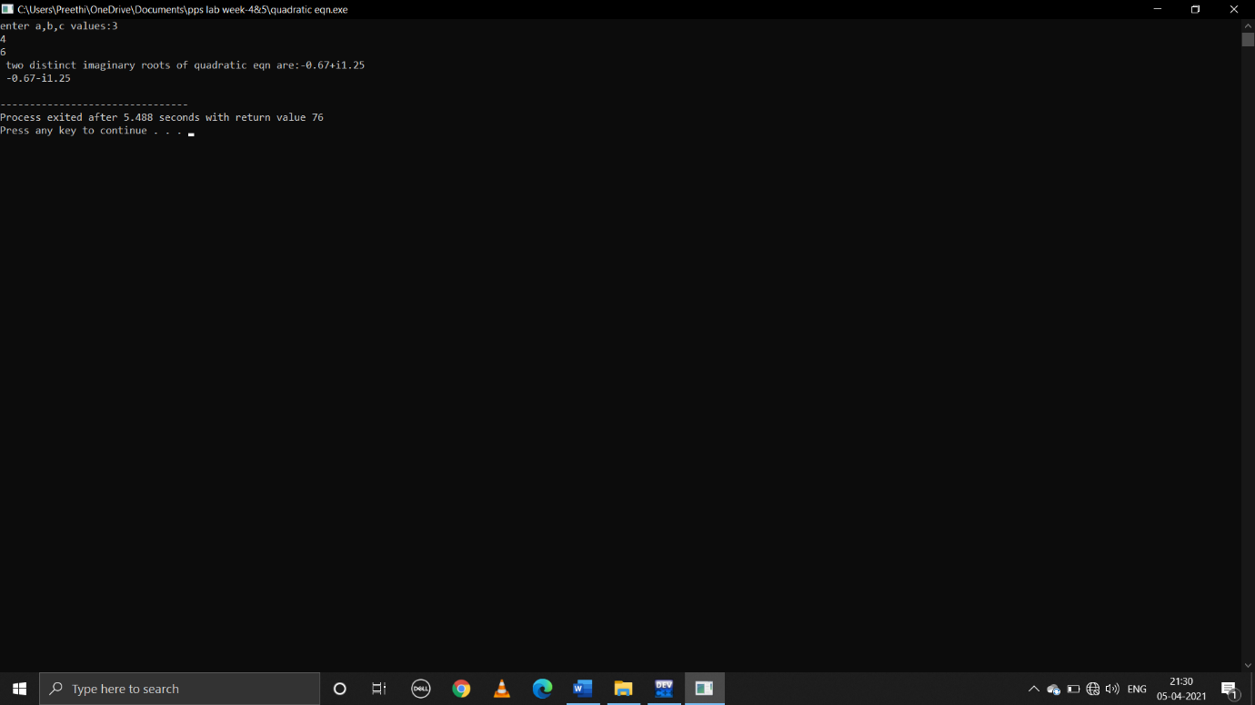

**7.Given as input three integers representing a date as day,month,year,print the number day,month and year for the next day’s date.Typical input:”28 2 1992” Typical output: ” Date following 28:02:1992 is 29:02:1992”**

**Pseudocode:**

Begin

Declare int d,m,y

Take user input values of date month year i,e;d,m,y

For months having 31 days

d>=1 and d<31

Print(d+1,m,y)

d==31 and m!==12

print(1,m+1,y)

d==31 and m==12

print(1,1,y+1)

for m==2

if it is a leap year

d>=1 and d<29

print(d+1,m,y)

d==29

print(1,m+1,y)

if it is not a leap year

d>=1 and d<28

print(d+1,m,y)

d==28

print(1,m+1,y)

for months having 30 days

d>=1 and d<30

print(d+1,m,y)

d==30

print(1,m+1,y)

end

**C program:**

#include<stdio.h>

void main()

{

int d,m,y;

printf("enter date :");

scanf("%d",&d);

printf("enter month:");

scanf("%d",&m);

printf("enter year:");

scanf("%d",&y);

if(m==1||m==3||m==5||m==7||m==8||m==10||m==12)

{

if(d>=1&&d<31)

{

printf("date following %d:%d:%d is %d:%d:%d\n",d,m,y,d+1,m,y);

}

else if(d==31&&m!=12)

{

printf("date following %d:%d:%d is %d:%d:%d\n",d,m,y,1,m+1,y);

}

else if(d==31&&m==12)

{

printf("date following %d:%d:%d is %d:%d:%d\n",d,m,y,1,1,y+1);

}

}

else if(m==2)

{

if((y%4==0&&y%100!=0)||y%400==0)

{

if(d>=1&&d<29)

{

printf("date following %d:%d:%d is %d:%d:%d\n",d,m,y,d+1,m,y);

}

else if(d==29)

{

printf("date following %d:%d:%d is %d:%d:%d\n",d,m,y,1,m+1,y);

}

}

else

{

if(d>=1&&d<28)

{

printf("date following %d:%d:%d is %d:%d:%d\n",d,m,y,d+1,m,y);

}

else if(d==28)

{

printf("date following %d:%d:%d is %d:%d:%d\n",d,m,y,1,m+1,y);

}

}

}

else if(m==4||m==6||m==9||m==11)

{

if(d>=1&&d<30)

{

printf("date following %d:%d:%d is %d:%d:%d\n",d,m,y,d+1,m,y);

}

else if(d==30)

{

printf("date following %d:%d:%d is %d:%d:%d\n",d,m,y,1,m+1,y);

}

}

else

{

printf("entered wrong month");

}

}

**Output:**

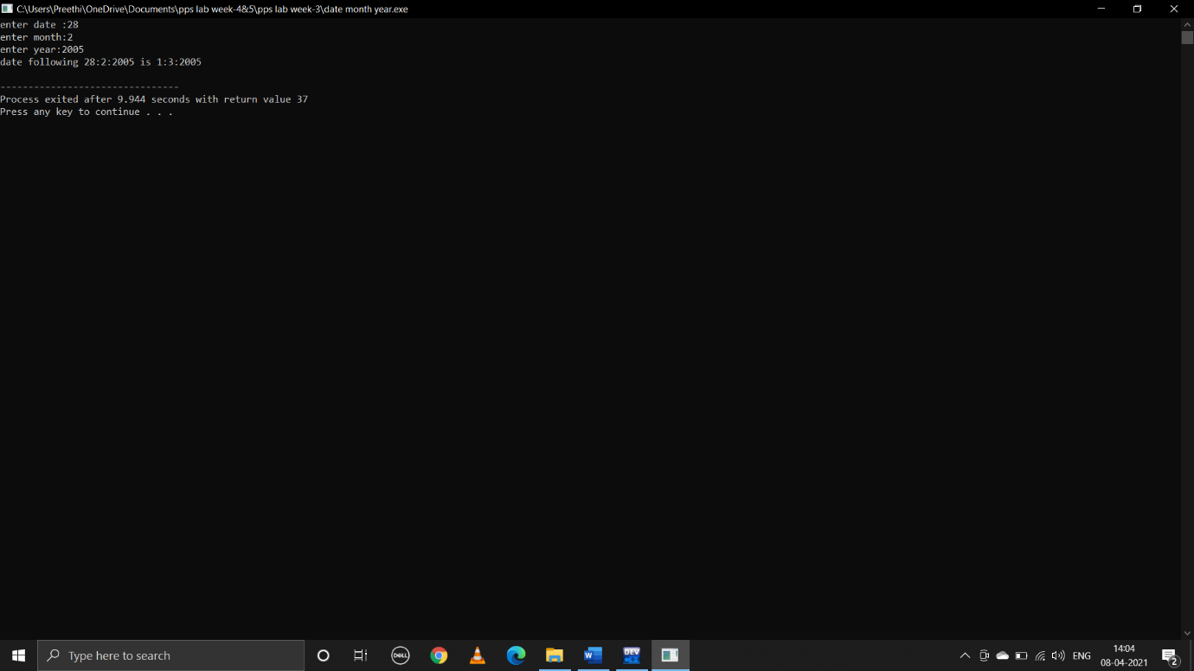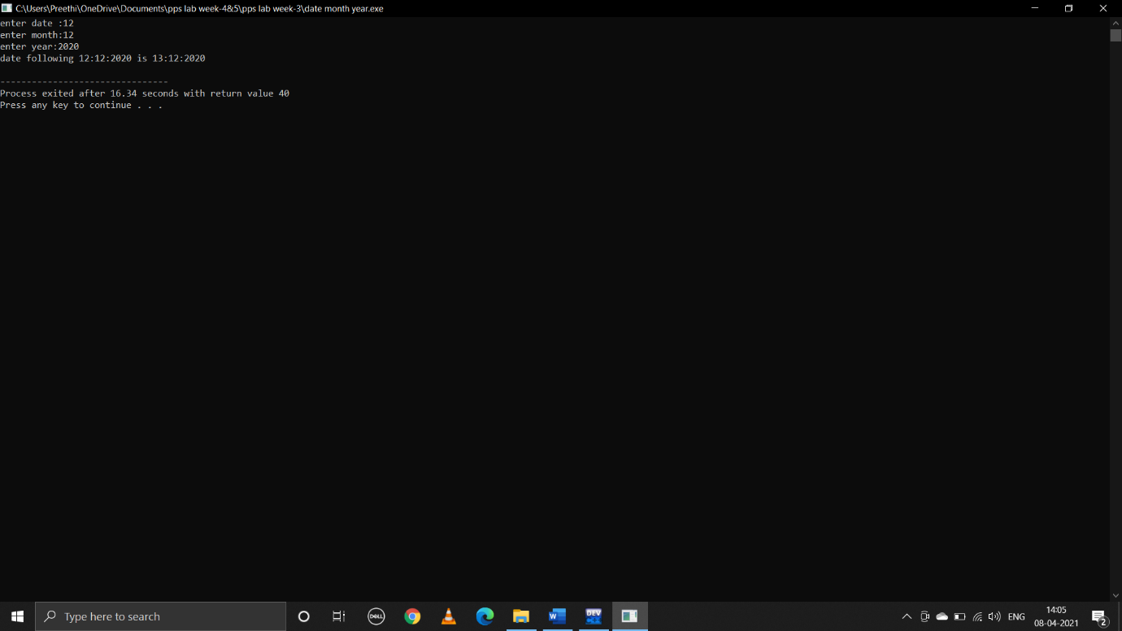

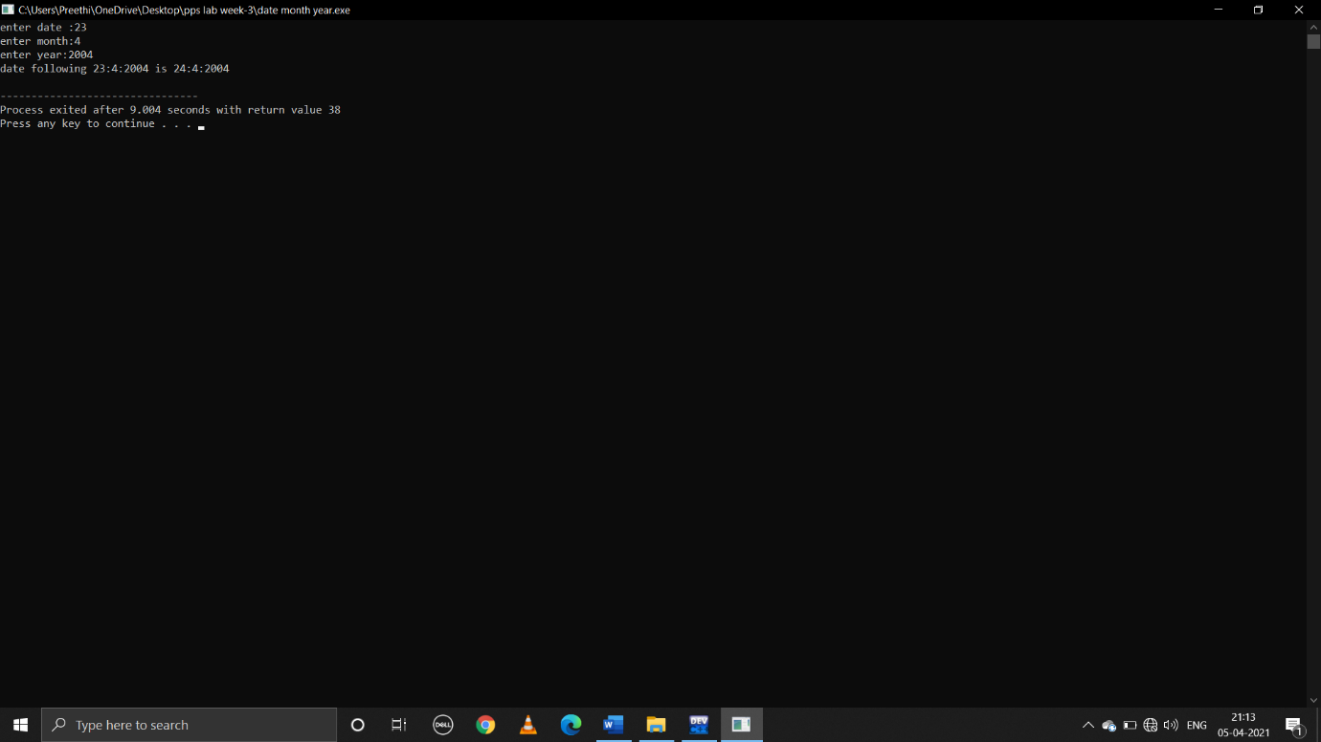

**WEEK-6**

**1.Write a C program to perform the basic Matrix operations**

**i)addition**

**pseudocode:**

begin

declare int rows,columns,i,j

take user input number of rows and columns

take user input elements of 1st matrix

so,declare an array int a[rows][columns]

run loop from i=0 to i<rows by increment i by 1

take another loop from j=0 to j<columns by increment j by 1

take user input a[i][j] element

declare another array for matrix b

take user input elements of matrix b

declare another array for sum matrix b

sum[rows][columns]

add element of matrix a with matrix b and update sum

run loops across rows and columns

sum[i][j]=a[i][j]+b[i][j]

print sum

end

**C program:**

#include<stdio.h>

void main()

{

int rows,columns,i,j;

printf("enter no.of rows:\n");

scanf("%d",&rows);

printf("enter no.of columns:\n");

scanf("%d",&columns);

printf("enter elements in 1st matrix");

int a[rows][columns];

for(i=0;i<rows;i++)

{

for(j=0;j<columns;j++)

{

printf("element-%d%d:",i,j);

scanf("%d",&a[i][j]);

}

}

int b[rows][columns];

printf("enter elements in 2nd matrix");

for(i=0;i<rows;i++)

{

for(j=0;j<columns;j++)

{

printf("element-%d%d:",i,j);

scanf("%d",&b[i][j]);

}

}

int sum[rows][columns];

for(i=0;i<rows;i++)

{

for(j=0;j<columns;j++)

{

sum[i][j]=a[i][j]+b[i][j];

}

}

printf("sum of two matrices is:");

for(i=0;i<rows;i++)

{

printf("\n");

for(j=0;j<columns;j++)

{

printf("%d ",sum[i][j]);

}

}

}

**Output:**

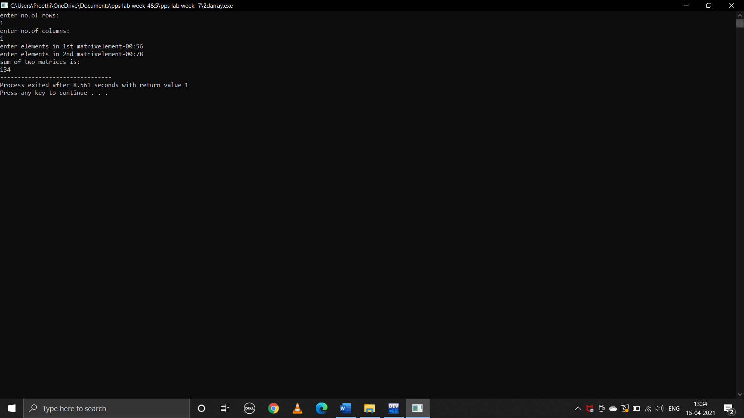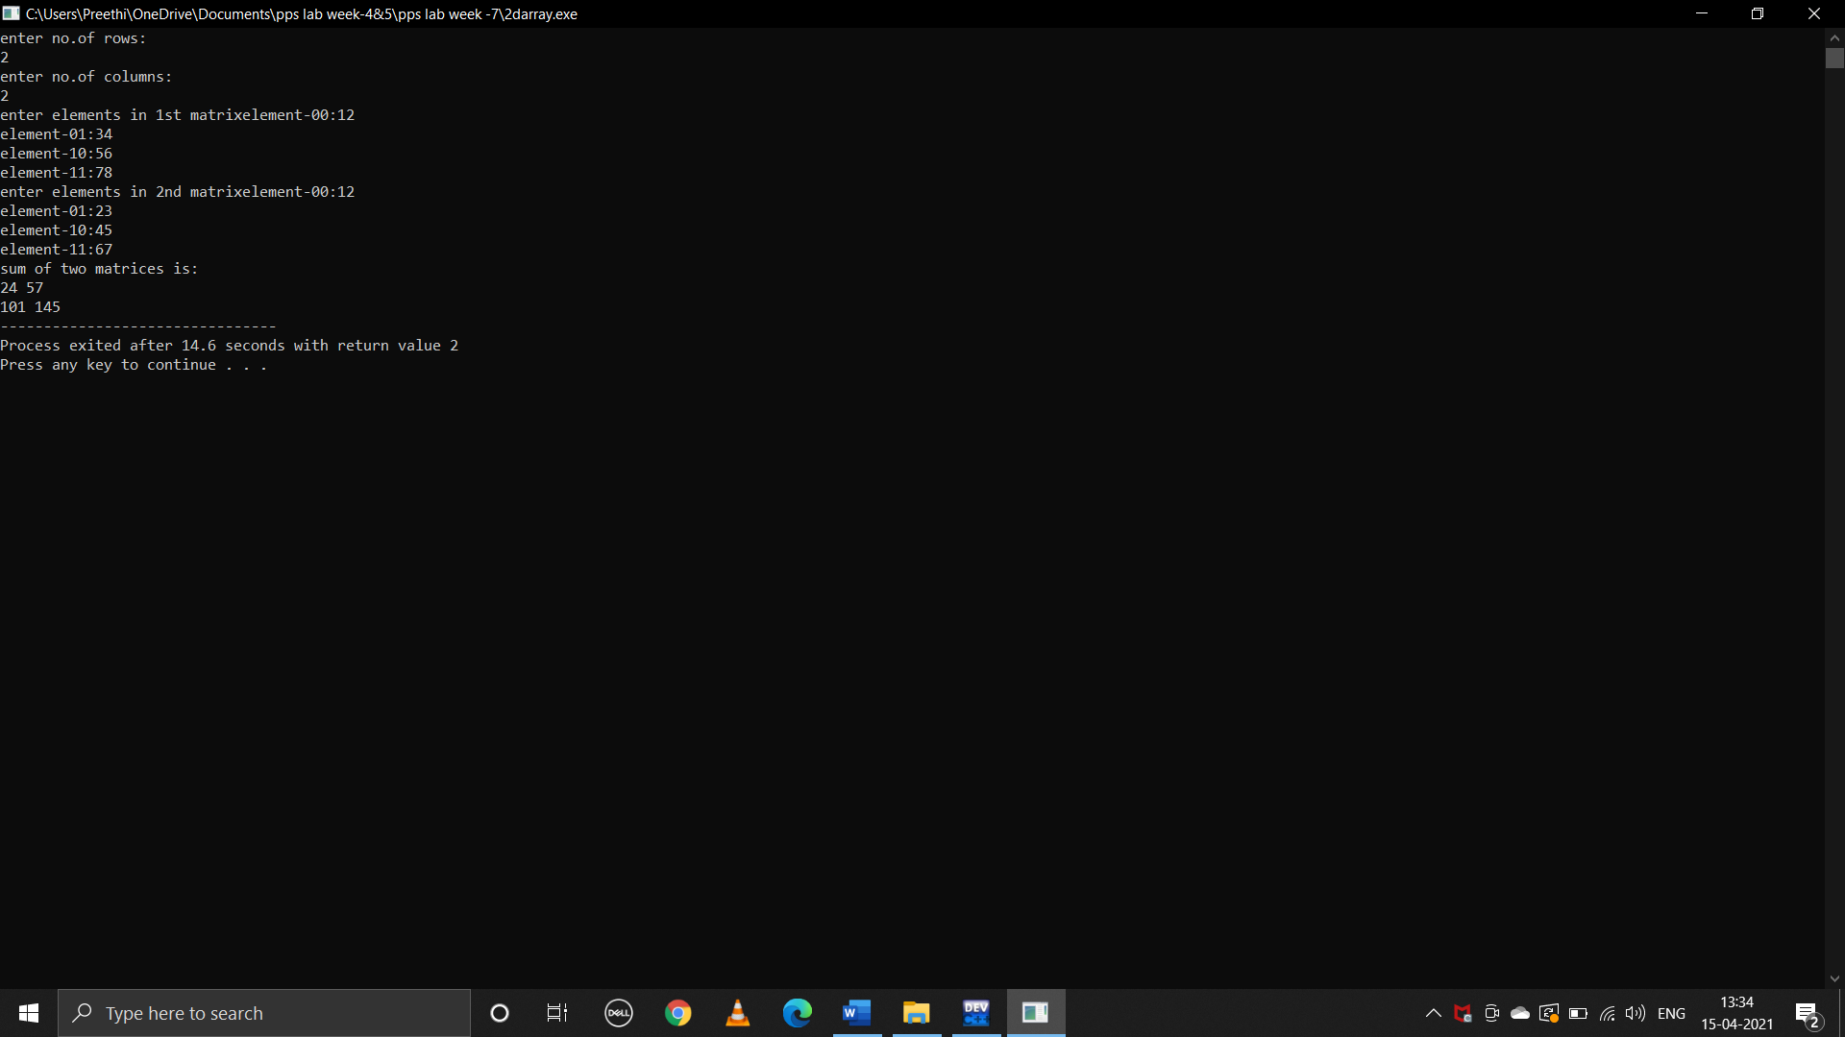

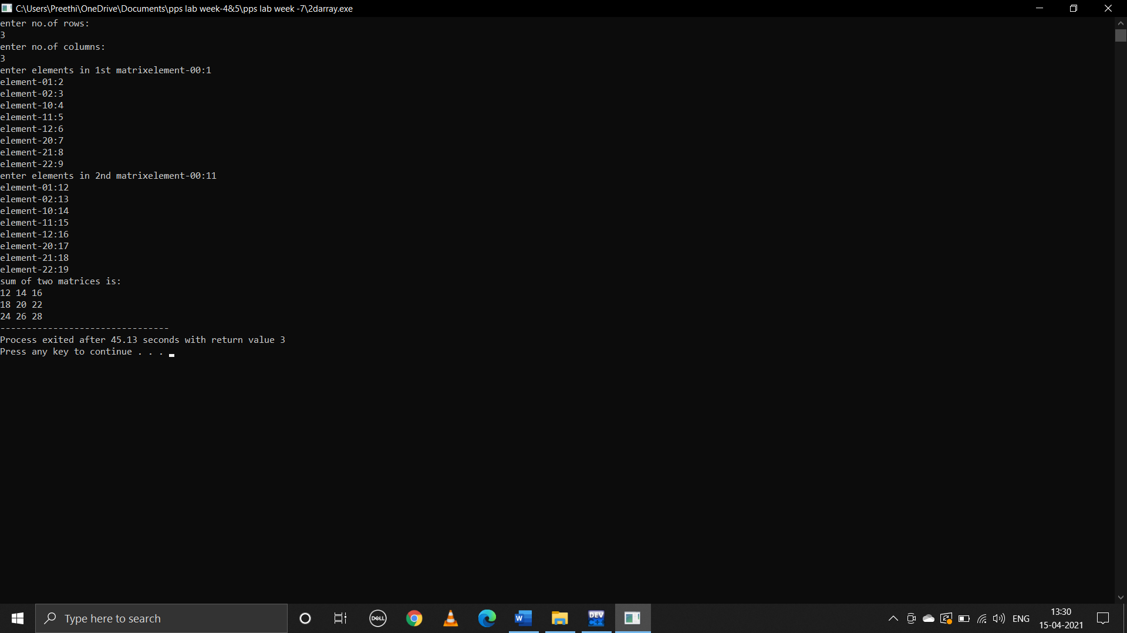

**ii)subtraction:**

**pseudocode:**

begin

declare int rows,columns,i,j

take user input number of rows and columns

take user input elements of 1st matrix

so,declare an array int a[rows][columns]

run loop from i=0 to i<rows by increment i by 1

take another loop from j=0 to j<columns by increment j by 1

take user input a[i][j] element

declare another array for matrix b

take user input elements of matrix b

declare another array for sum matrix b

sub[rows][columns]

subtract element of matrix a with matrix b and update sum

run loops across rows and columns

sub[i][j]=a[i][j]-b[i][j]

print sub

end

**c program:**

#include<stdio.h>

void main()

{

int rows,columns,i,j;

printf("enter no.of rows:\n");

scanf("%d",&rows);

printf("enter no.of columns:\n");

scanf("%d",&columns);

printf("enter elements in 1st matrix");

int a[rows][columns];

for(i=0;i<rows;i++)

{

for(j=0;j<columns;j++)

{

printf("element-%d%d:",i,j);

scanf("%d",&a[i][j]);

}

}

int b[rows][columns];

printf("enter elements in 2nd matrix");

for(i=0;i<rows;i++)

{

for(j=0;j<columns;j++)

{

printf("element-%d%d:",i,j);

scanf("%d",&b[i][j]);

}

}

int sub[rows][columns];

for(i=0;i<rows;i++)

{

for(j=0;j<columns;j++)

{

sub[i][j]=a[i][j]-b[i][j];

}

}

printf("subtraction of two matrices is:");

for(i=0;i<rows;i++)

{

printf("\n");

for(j=0;j<columns;j++)

{

printf("%d ",sub[i][j]);

}

}

}

**output:** 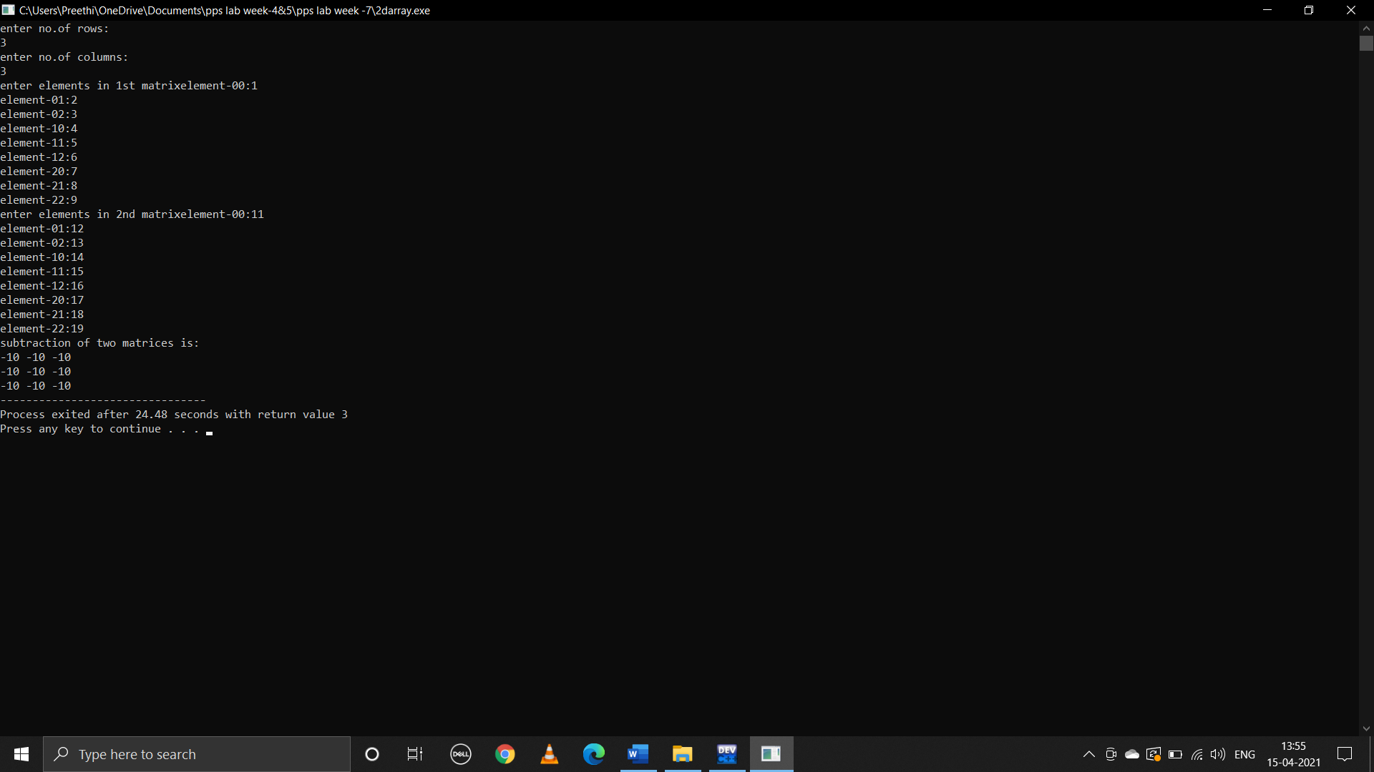

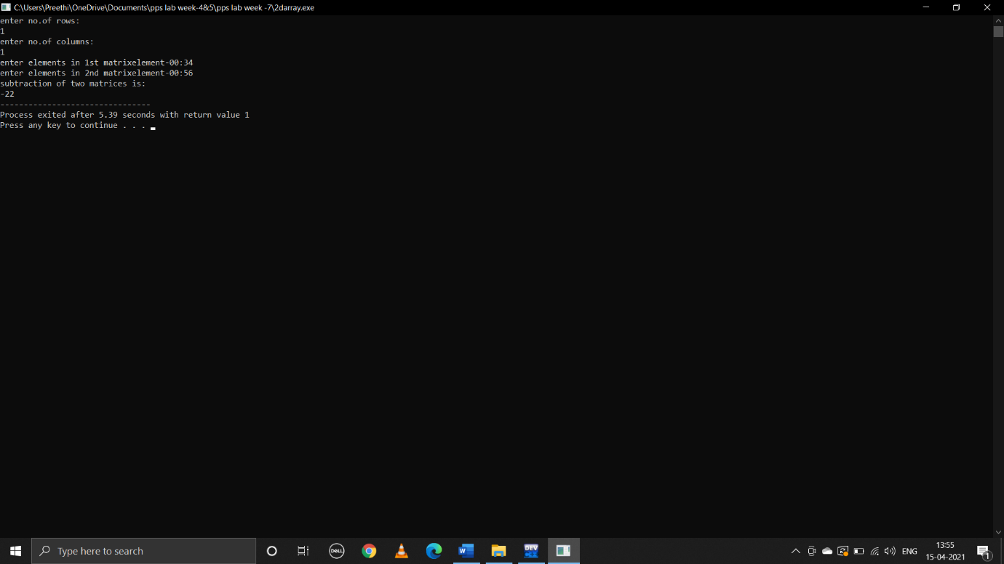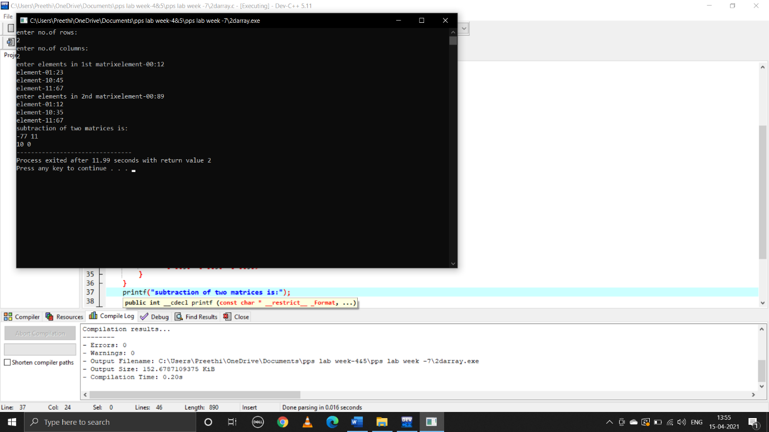

**iii)Multiplication**

**pseudocode:**

begin

declare int i,j,r1,c1,r2,c2,sum=0,multiply[100][100]

take user input values for number rows and columns of for matrix a and b

take user input enteries into both the matrices

if(c1!=r2)

print(multiplication is not possibble)

else

for(i=0;i<r1;i++)

for(j=0;j<c2;j++)

for(k=0;k<r2;k++)

sum=sum+a[i][k]*b[k][j]

multiply[i][j]=sum

sum=0

print multiply

end

**C program:**

#include<stdio.h>

void main()

{

int i,j,r1,c1,r2,c2,sum=0,k,multiply[100][100];

printf("enter rows for 1st matrix:");

scanf("%d",&r1);

printf("enter columns for 1st matrix:");

scanf("%d",&c1);

int a[r1][c1];

for(i=0;i<r1;i++)

{

for(j=0;j<c1;j++)

{

printf("enter %d%d element:",i,j);

scanf("%d",&a[i][j]);

}

}

for(i=0;i<r1;i++)

{

printf("\n");

for(j=0;j<c1;j++)

{

printf("%d ",a[i][j]);

}

}

printf("\n");

printf("enter rows for 2nd matrix:");

scanf("%d",&r2);

printf("enter columns for 2nd matrix:");

scanf("%d",&c2);

int b[r2][c2];

for(i=0;i<r2;i++)

{

for(j=0;j<c2;j++)

{

printf("enter %d%d element:",i,j);

scanf("%d",&b[i][j]);

}

}

for(i=0;i<r2;i++)

{

printf("\n");

for(j=0;j<c2;j++)

{

printf("%d ",b[i][j]);

}

}

printf("\n");

if(c1!=r2)

{

printf("multiplication is not possible");

}

else

{

for(i=0;i<r1;i++)

{

for(j=0;j<c2;j++)

{

for(k=0;k<r2;k++)

{

sum=sum+a[i][k]*b[k][j];

}

multiply[i][j]=sum;

sum=0;

}

}

printf("\n");

printf("product of entered matrices:\n");

for(i=0;i<r1;i++)

{

printf("\n");

for(j=0;j<c2;j++)

{

printf("%d ",multiply[i][j]);

}

}

}

}

**Output:**

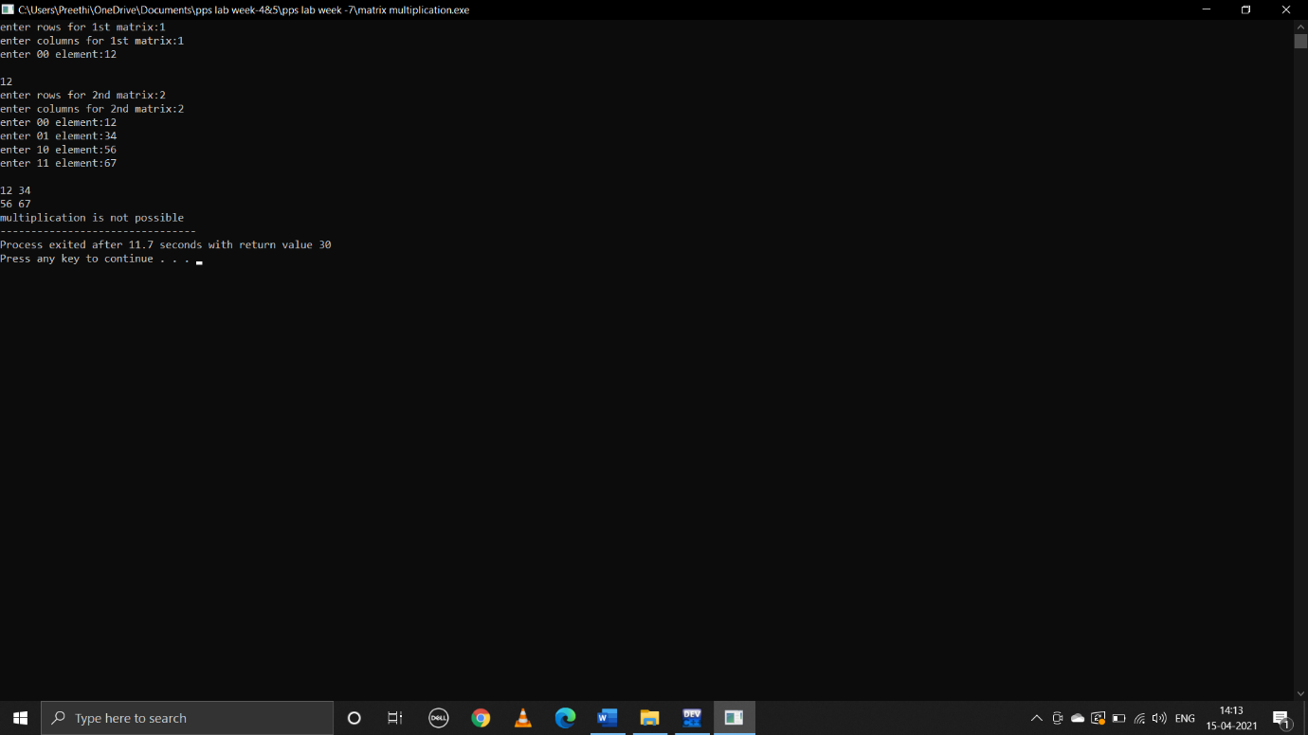

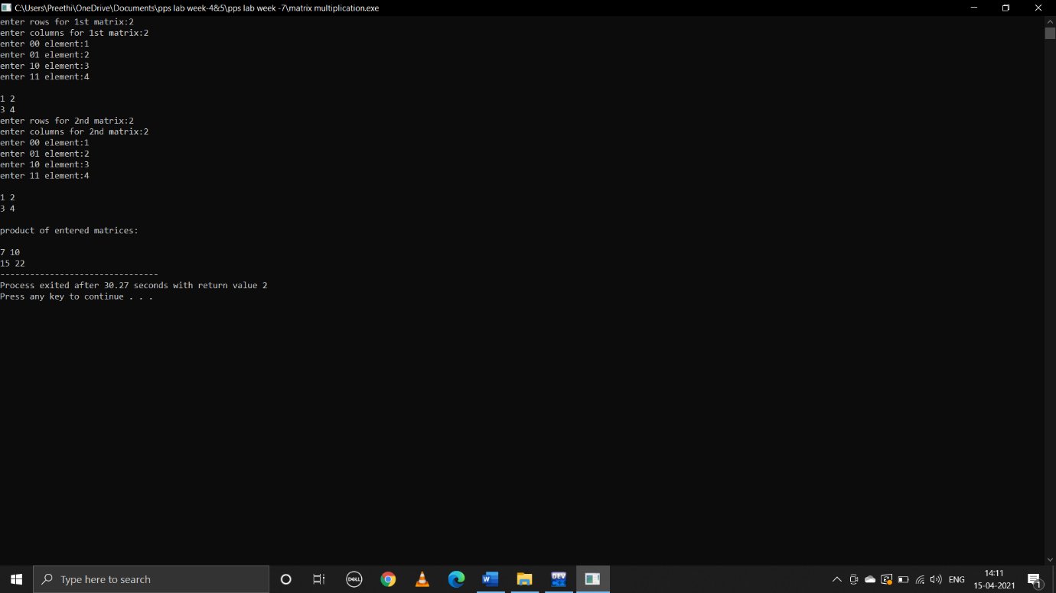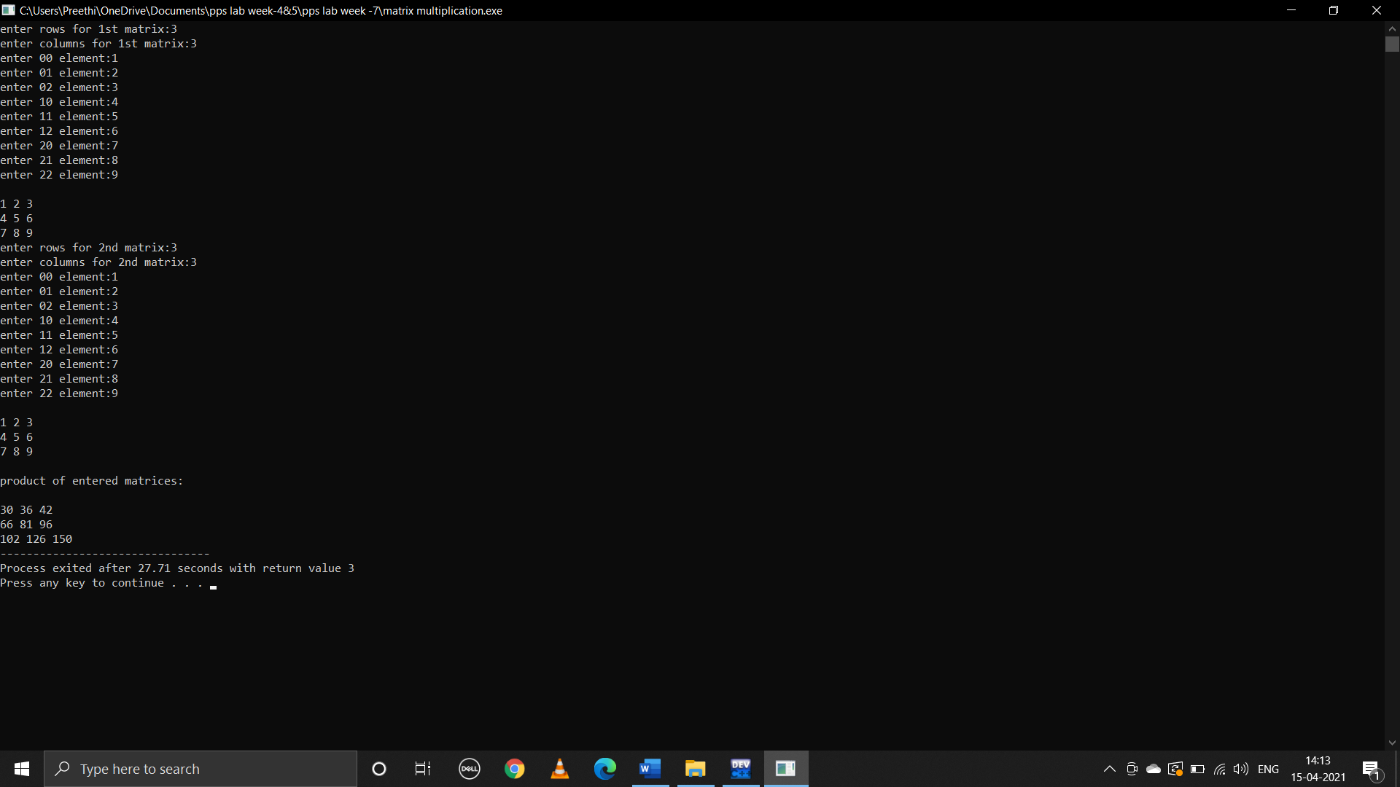

**iv)Transpose**

**pseudocode:**

begin

declare int r1,c1,i,j

take user input values for number of rows and columns

take user input entries into the matrix

declare another matrix trans[c1][r1]

interchange rows and columns

for(i=0;i<r1;i++)

for(j=0;j<c1;j++)

trans[j][i]=a[i][j]

print(trans)

end

**C program:**

#include<stdio.h>

void main()

{

int r1,c1,i,j;

printf("enter no.of rows of 1st matrix:");

scanf("%d",&r1);

printf("enter no.of columns of 1st matrix:");

scanf("%d",&c1);

int a[r1][c1];

printf("enter elements of matrix a\n");

for(i=0;i<r1;i++)

{

for(j=0;j<c1;j++)

{

printf("enter element-%d%d:",i,j);

scanf("%d",&a[i][j]);

}

}

for(i=0;i<r1;i++)

{

printf("\n");

for(j=0;j<c1;j++)

{

printf("%d ",a[i][j]);

}

}

printf("\n");

int trans[c1][r1];

for(i=0;i<r1;i++)

{

for(j=0;j<c1;j++)

trans[j][i]=a[i][j];

}

printf("transpose of matrix is:\n");

for(i=0;i<r1;i++)

{

printf("\n");

for(j=0;j<c1;j++)

printf("%d ",trans[i][j]);

}

}

**Output:**

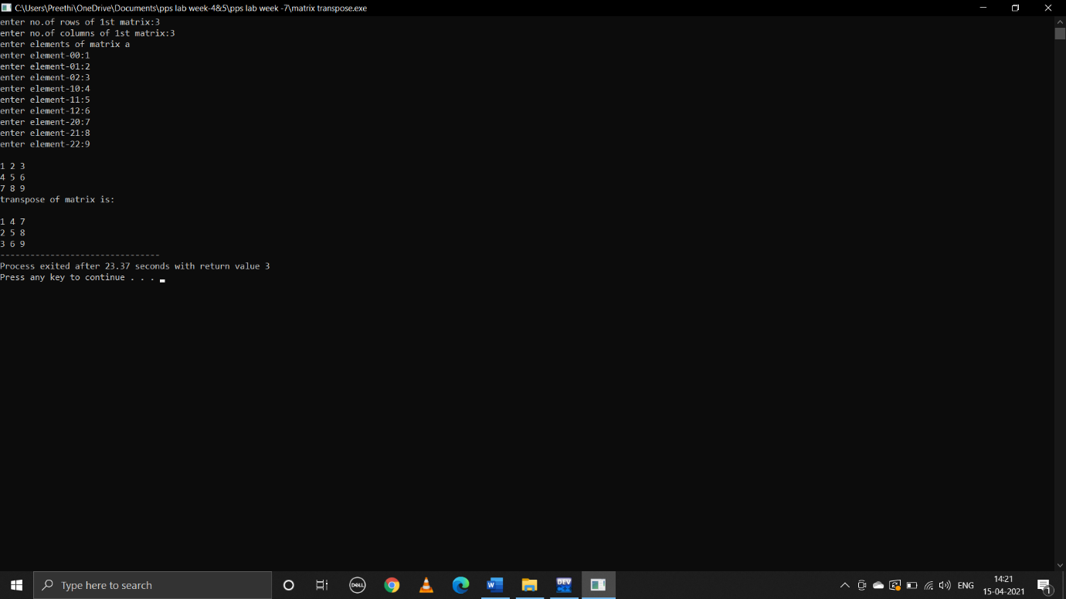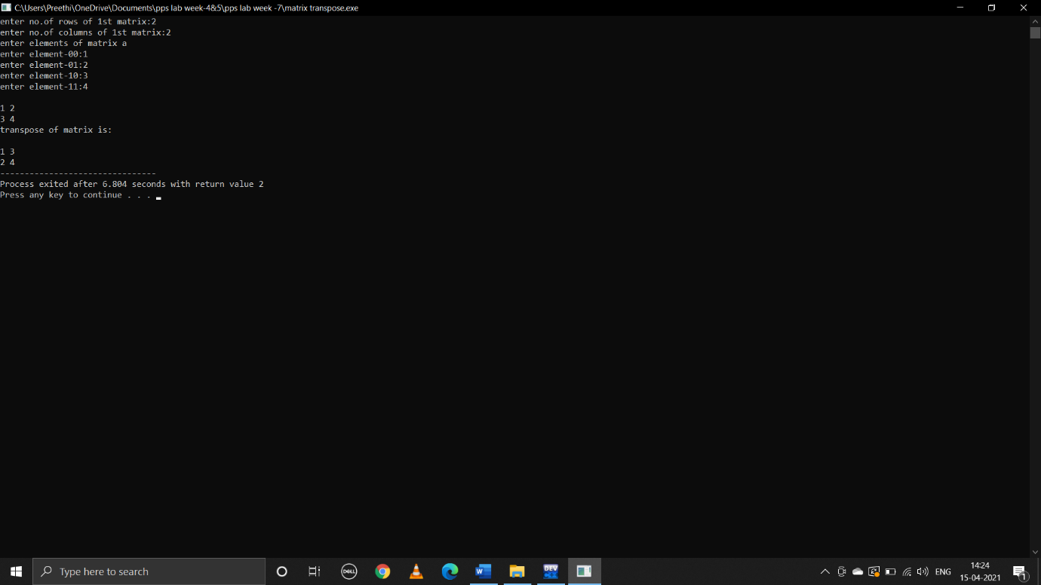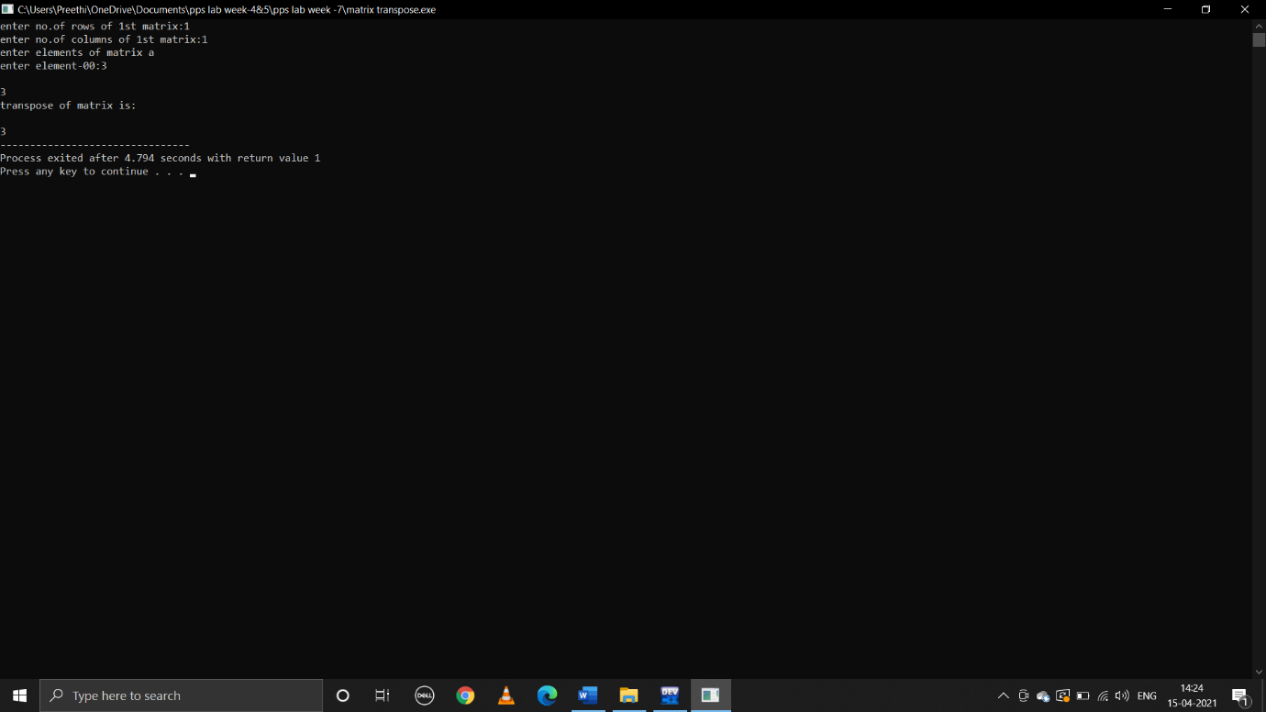

**2.write a C program to determine if the given string is a palindrome or not**

**Pseudocode:**

Begin

Declare string[1000]

Take user input string

Declare int i,len,count=0

len=strlen(string)

run loop across length of the string

if(string[i]==string[len-i-1])

count=count+1;

if len==count

print(palindrome)

else

print(not a palindrome)

end

**C program:**

#include<stdio.h>

#include<string.h>

void main()

{

char string[1000];

printf("enter any string:");

gets(string);

puts(string);

int i,len,count=0;

len=strlen(string);

for(i=0;i<len;i++)

{

if(string[i]==string[len-i-1])

count=count+1;

}

if(count==len)

{

printf("palindrome");

}

else

{

printf("not a palindrome");

}

}

**Output:**

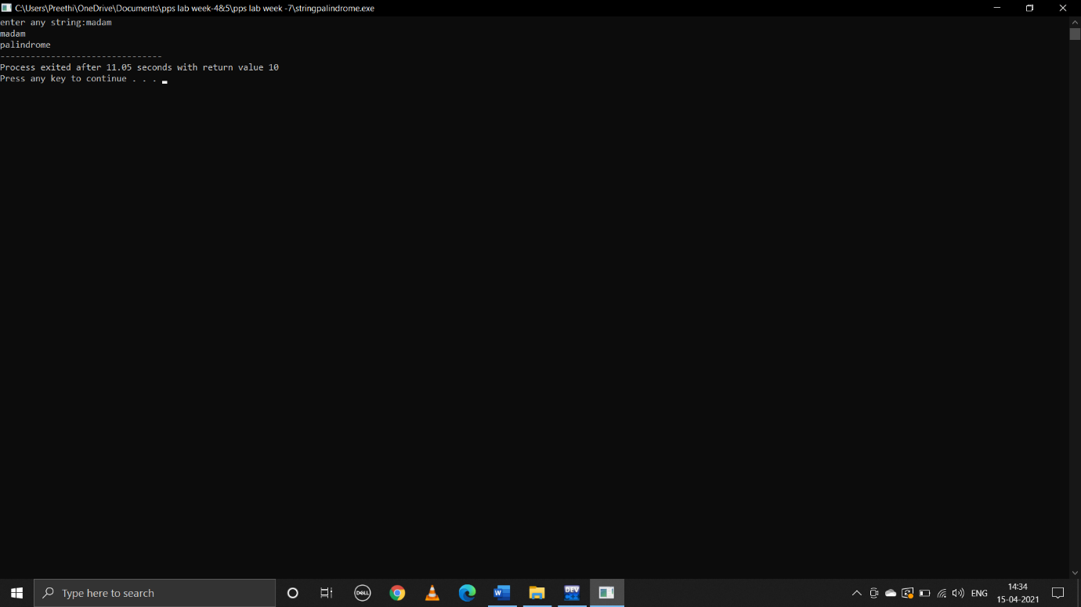

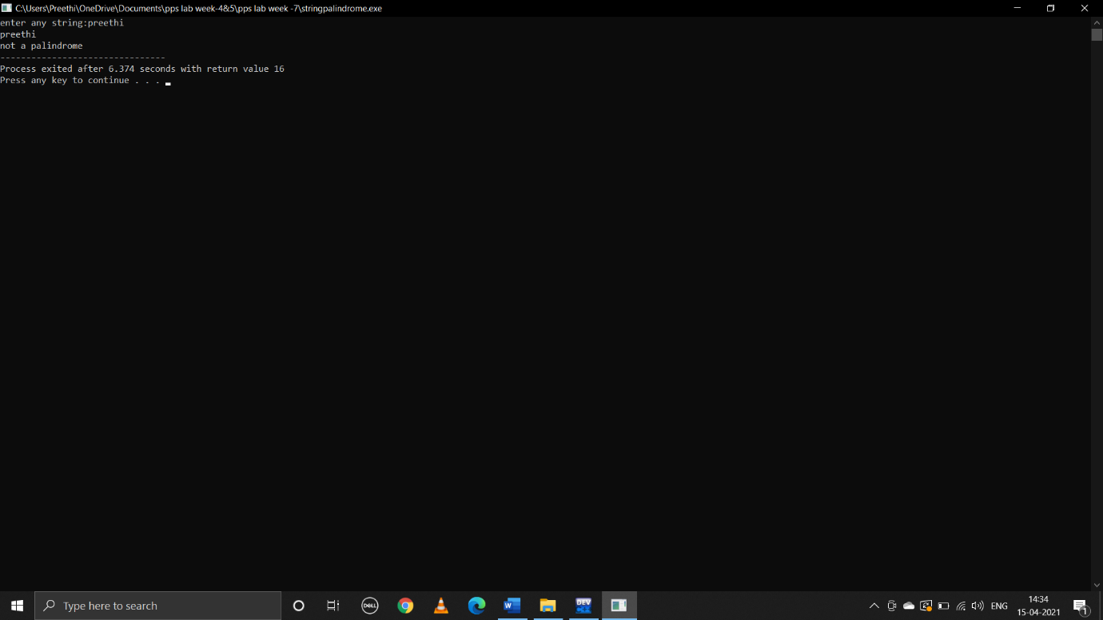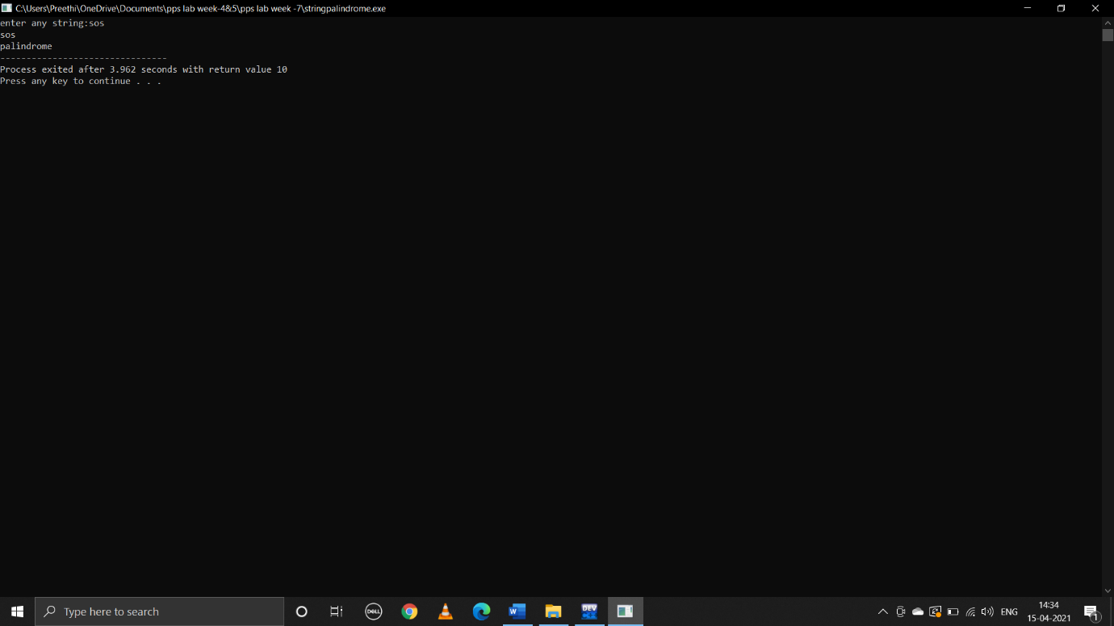

**3.write a C program to count the lines,words and characters in a given text**

**Pseudocode:**

Begin

Declare string s[100]

Int i,line=0,word=0,ch=0

Take user input paragraph terminated with ~

Run loop from i=0 to s[i]=’\0’

If s[i]=='\n'

line++

word++

else

if s[i]==' '||s[i]=='\t

word++

ch++

else

ch++

print(line,word ,ch)

end

**C program:**

#include<stdio.h>

#include<string.h>

void main()

{

char s[100];

int i,line=0,word=0,ch=0;

printf("enter paragraph terminated with ~:");

scanf("%[^~]",s);

for(i=0;s[i]!='\0';i++)

{

if(s[i]=='\n')

{

line++;

word++;

}

else

{

if(s[i]==' '||s[i]=='\t')

{

word++;

ch++;

}

else

{

ch++;

}

}

}

printf("no.of lines is:%d\n",line+1);

printf("no.of characters are:%d\n",ch);

printf("no.of words are :%d\n",word+1);

}

**Output:** 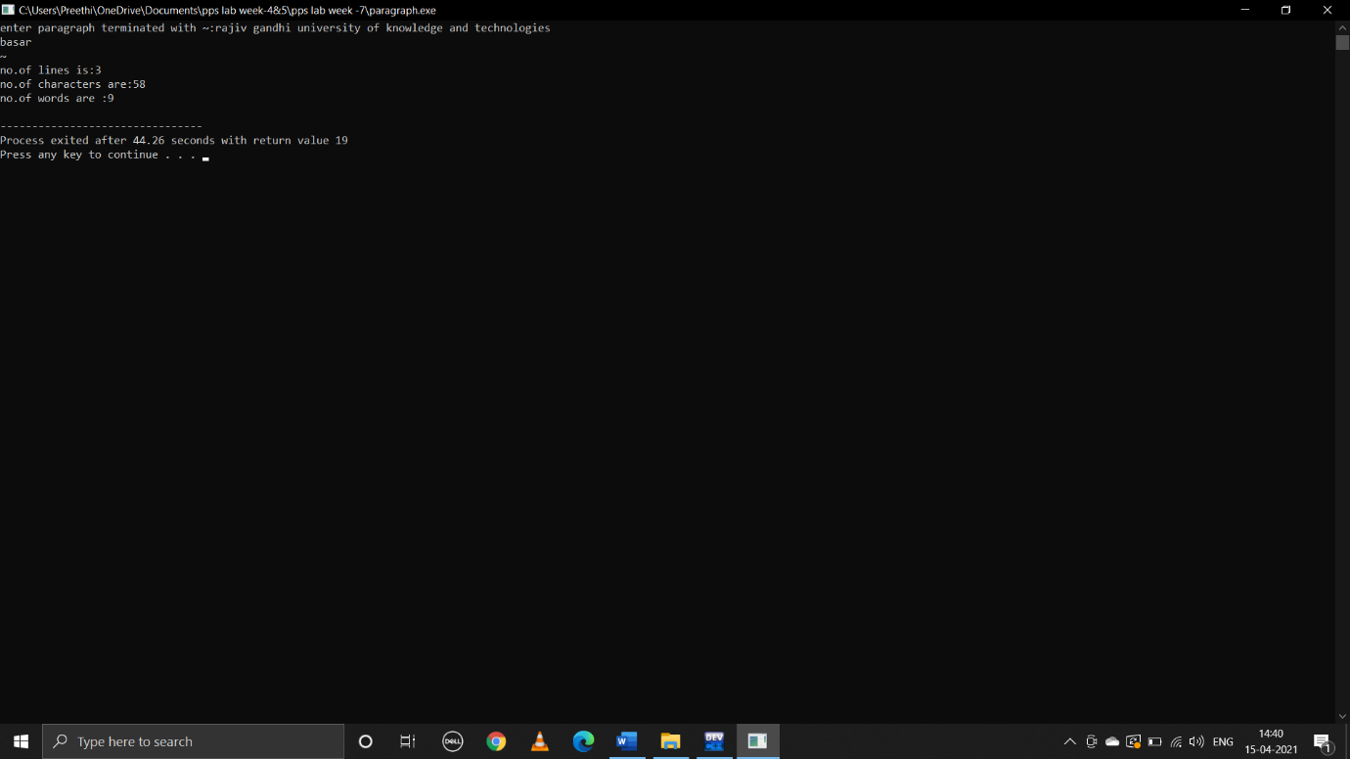

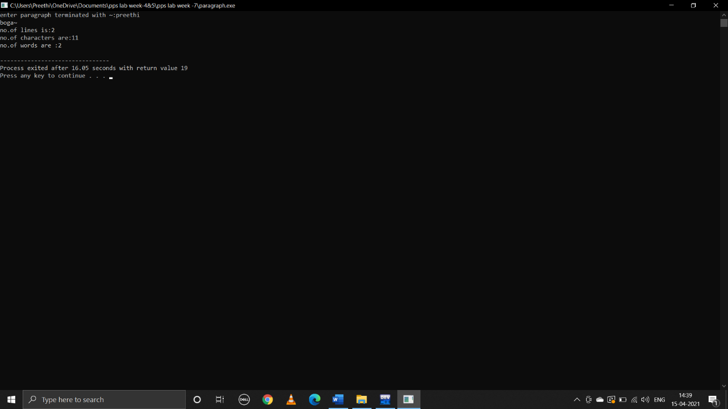

Done by:

B.preethi

ID:B181356

Class:E1-CSE,AB-2,305

